**COMSATS University Islamabad, Pakistan**

**Community Service Provider**

**By**

**Sheraz Kamran SP17-BSE-014/ATK**

**Ubaid-Ur-Rehman SP17-BSE-015/ATK**

**Usama Malik SP17-BSE-034/ATK**

**Supervisor**

**Mr. Muhammad Kamran**

***Bachelor of Science in Computer Science (2017-2021)***

The candidate confirms that the work submitted is their own and appropriate credit has been given where reference has been made to the work of others.



**COMSATS University, Islamabad Pakistan**

**Community Service Provider**

**A project presented to**

**COMSATS University, Islamabad**

**In partial fulfillment**

**Of the requirement for the degree of**

***Bachelor of Science in Computer Science (2017-2021)***

**By**

**Sheraz Kamran SP17-BSE-014/ATK**

**Ubaid-Ur-Rehman SP17-BSE-015/ATK**

**Usama Malik SP17-BSE-034/ATK**

**­­­­­­**

**DECLARATION**

*We hereby declare that this software, neither whole nor as a part has been copied out from any source. It is further declared that we have developed this software and accompanied report entirely on the basis of our personal efforts. If any part of this project is proved to be copied out from any source or found to be reproduction of some other. We will stand by the consequences. No Portion of the work presented has been submitted of any application for any other degree or qualification of this or any other university or institute of learning.*

Sheraz Kamran Ubaid-Ur-Rehman Usama Malik

--------------------------- --------------------------- -------------------------

**CERTIFICATE OF APPROVAL**

It is to certify that the final year project of BS(SE) **“*Community Service Provider*”** was developed by **Sheraz Kamran (CIIT/SP17-BSE/014)**, **Ubaid-Ur-Rehman (CIIT/SP17-BSE/015)** and **Usama Malik (CIIT/SP17-BSE/34)** under the supervision of **“Mr. Mohammad Kamran”** and that in his opinion; it is fully adequate, in scope and quality for the degree of Bachelors of Science in Computer Sciences.

---------------------------------------

**Supervisor**

**---------------------------------------**

**External Examiner**

---------------------------------------

**Head of Department**

**(Department Computer Science)**

# **Table of Content**

Table of Content 5

Table of Figures 7

Table of Tables 9

1 Introduction 11

**1.1** **Brief** 11

**1.2** **Relevance to Course Modules** 11

**1.2.1** **Project Domain** 11

**1.2.2** **Project Development and Testing** 11

**1.3** **Project** **Background** 12

**1.3.1** **Shop** 13

**1.3.2** **BookIt** 13

**1.3.3** **Hire** **Service** 13

**1.3.4** **Pay** **Bills** 13

**1.3.5** **Complain** 14

**1.4** **Literature** **Review** 14

**1.5** **Analysis from Literature Review** 14

**1.6** **Methodology and Software Lifecycle for This Project** 14

**1.6.1** **Methodology** 14

**1.6.2** **SDLC** 15

**1.6.3** **Rationale behind Selected Methodology** 15

2 Problem Definition 15

**2.1** **Problem** **Statement** 15

**2.2** **Deliverables and Development Requirements** 16

**2.2.1** **Deliverables** 16

**2.2.2** **Development Requirements** 16

**2.3** **Current System** 17

**2.3.1** **Amazon** 17

**2.3.2** **Pakistan Citizen Portal** 17

3 Requirements Analysis 18

**3.1** **Use Cases Diagram(s)** 18

**3.1.1** **Sign Up** 18

**3.1.2** **Shop** 19

**3.1.3** **BookIt** 20

**3.1.4** **Hire Service** 21

**3.1.5** **Pay Bills** 21

**3.1.6** **Complain** 22

**3.2** **Detailed Use Case** 22

**3.2.1** **Signing Up** 22

**3.2.2** **Online Shopping** 24

**3.2.3** **Online Service Hiring** 26

**3.2.4** **Online Billing** 27

**3.2.5** **Online Booking** 28

**3.2.6** **Online Complain** 29

**3.3** **Requirements** 30

**3.3.1** **Functional requirements** 31

**3.3.2** **Non-functional requirements** 32

4 Design and Architecture 33

**4.1** **System Architecture** 34

**4.1.1** **Flow chart Diagram** 34

**Description:** 34

**4.2** **Data Representation** 35

**4.2.1** **Data Flow Diagram (level 0)** 35

**4.2.2** **Data Flow Diagram (level 1)** 35

**4.2.3** **Data Flow Diagram (level 2)** 36

**4.3** **Process Flow/Description** 42

**4.3.1** **Activity Diagram** 42

**4.3.2** **Sequence Diagram** 44

**4.4** **Design Models** 49

**4.4.1** **Entity Relation Diagram** 49

5 Implementation 50

**5.1** **Methodology** 50

**5.2** **Development Stages** 50

**5.2.1** **Installation of Tools** 50

**5.3** **Tools & Technology Used** 52

**5.4** **User Interface** 53

**5.4.1** **User End Website** 53

**5.4.2** **User End Android App** 61

**5.4.3** **Management End Web Portal** 66

6 Evaluation and Testing 69

**6.1** **Testing Objectives** 69

**6.2** **Selected testing methodology** 69

7 Conclusion & Future Work 72

**7.1** **Vision** 72

**7.2** **Conclusion** 72

**7.3** **Future Work** 72

8 References 73

# **Table of Figures**

Figure 1: Sample Picture 15

Figure 2: Sign Up Use Case Diagram 18

Figure 3: Shop Use case Diagram 19

Figure 4: BookIt Use case Diagram 20

Figure 5: Hire Service Use Case 21

Figure 6: Billing Use Case Diagram 21

Figure 7: Complain Use Case Diagram 22

Figure 8: Flow Chart 34

Figure 9: Data Flow Diagram (Level 0) 35

Figure 10: Data Flow Diagram (Level 1) 36

Figure 11: Online Shopping DFD (Level 2) 37

Figure 12: Online Booking DFD (Level 2) 38

Figure 13: Online Service Hiring DFD (Level 2) 39

Figure 14: Online Billing DFD (Level 2) 40

Figure 15: Online Complain DFD (Level 2) 41

Figure 16: Activity Diagram (User-End) 42

Figure 17: Activity Diagram (Manager-End) 43

Figure 18: Sign Up Sequence Diagram 44

Figure 19: Online Shopping Sequence Diagram 45

Figure 20: Online Booking Sequence Diagram 46

Figure 21: Online Service Hiring Sequence Diagram 46

Figure 22: Online Billing Sequence Diagram 47

Figure 23: Online Complain Sequence Diagram 48

Figure 24: ERD 49

Figure 25: VS Code 50

Figure 26: Xampp Server 51

Figure 27: MySQL (phpMyAdmin) 51

Figure 28: Android Studio 52

Figure 29: Login Screen (User End Website) 53

Figure 30: Signup Screen (User End Website) 54

Figure 31: Home Screen 1 (User End Website) 54

Figure 32: Home Screen 2 (User End Website) 55

Figure 33: Home Screen 3 (User End Website) 55

Figure 34: Shop Screen 1 (User End Website) 56

Figure 35: Shop Screen 2 (User End Website) 56

Figure 36: Shop Screen 3 (User End Website) 57

Figure 37: Booking Screen 1 (User End Website) 57

Figure 38: Booking Screen 2 (User End Website) 58

Figure 39: Hire Service Screen 1 (User End Website) 58

Figure 40: Hire Service Screen 2 (User End Website) 59

Figure 41: Pay Bills Screen 1 (User End Website) 59

Figure 42: Pay Bills Screen 2 (User End Website) 60

Figure 43: Complain Screen 1 (User End Website) 60

Figure 44: Complain Screen 2 (User End Website) 61

Figure 45: Login Screen (User End App) 61

Figure 46: Sign Up Screen (User End App) 62

Figure 47: Home Screen (User End App) 62

Figure 48: Shop Screen 1 (User End App) 63

Figure 49: Shop Screen 2 (User End App) 63

Figure 50: Hire Service Screen (User End Android App) 64

Figure 51: Pay Bills Screen (User End Android App) 64

Figure 52: Complain Screen 1 (User End Android App) 65

Figure 53: Complain Screen 2 (User End Android App) 65

Figure 54: Login Screen (Manager End Web Portal) 66

Figure 55:Home Screen-User Manager (Manager End Web Portal) 66

Figure 56: Home Screen-Shop Manager (Manager End Web Portal) 67

Figure 57: Home Screen-Booking Manager (Manager End Web Portal) 67

Figure 58: Home Screen-Service Manager (Manager End Web Portal) 68

Figure 59: Home Screen-Billing Manager (Manager End Web Portal) 68

Figure 60: Home Screen-Complain Manager (Manager End Web Portal) 69

# **Table of Tables**

Table 1: Enter Name Use Case (Signing Up) 22

Table 2: Enter Email Use Case (Signing Up) 23

Table 3: Enter Password Use Case (Signing Up) 23

Table 4: Confirm Password Use Case (Signing Up) 23

Table 5: Create Account Use Case (Signing Up) 23

Table 6: Verify Use Case (Signing Up) 24

Table 7: Login Use Case (Online Shopping) 24

Table 8: View Details Use Case (Online Shopping) 24

Table 9: Add to Cart Use Case (Online Shopping) 24

Table 10: Checkout Use Case (Online Shopping) 25

Table 11: Logout Use Case (Online Shopping) 25

Table 12: View Order Use Case (Online Shopping) 25

Table 13: Generate Invoice Use Case (Online Shopping) 26

Table 14: Verify Use Case (Online Shopping) 26

Table 15: Select Service Use Case (Online Service Hiring) 26

Table 16: Send Hire Request Use Case (Online Service Hiring) 26

Table 17: View Request Use Case (Online Service Hiring) 27

Table 18: Cancel Request Use Case (Online Service Hiring) 27

Table 19: Verify Use Case (Online Service Hiring) 27

Table 20: Enter Bill ID Use Case (Online Billing) 27

Table 21: View Details Use Case (Online Billing) 28

Table 22: Pay Bill Use Case (Online Billing) 28

Table 23: Add New Bill Use Case (Online Billing) 28

Table 24: Select Vehicle Use Case (Online Booking) 28

Table 25: Confirm timings and Destination Use Case (Online Booking) 29

Table 26: Reserve Car Use Case (Online Booking) 29

Table 27: View Reservations Use Case (Online Booking) 29

Table 28: Confirm Request Use Case (Online Booking) 29

Table 29: Define Subject Use Case (Online Complain) 30

Table 30: Write Complaint Use Case (Online Complain) 30

Table 31: Send Request Use Case (Online Complain) 30

Table 32: Tools and Technologies 53

Table 33: Test Cases for User End / Website / Android App 70

Table 34: Test Cases for Management End / Web Portal 72

# **Introduction**

## **Brief**

Life is getting busier and busier day by day. Managing daily life needs has become quite a pain for such a person who has to coup with a lot of responsibilities; job related, business related, family related and even society related. The time factor gets tighter and tighter every day which can cause serious issues in a person’s life. It can also affect his health too.

Nowadays, there is a growing trend of building Town Communities in Pakistan. Even though, a town has a lot of privileges for its members, still it fails to provide these facilities in an easy and time-saving manner.

The main aim of *Community Service Provider* is to provide a specific town’s members the fast and easy access of its privileges (shopping, town bills, services, reserving a ride and putting complaints online). It is a cross platform (Android and Web) system that gives the online facility of shopping, booking a car, service hiring, billing, and complaining. The town members can buy groceries, shoes and garments, fast food, accessories, hire services, rent vehicles and pay town bills from anywhere within a few clicks.

The system has been developed using *Android Studio, bootstrap4-3.3-3.7.1 html5 and css3* for front-end and java and *php* for back-end*.* Incremental model is selected as its SDLC model.

## **Relevance to Course Modules**

### **Project Domain**

*Community Service Provider* has a business domain. Since the system provides online shopping, booking, billing etc. services, it requires basic knowhow of related terms and marketing strategies. Hence, the concepts which helped us were learned in

* **MGT101**: Introduction to Management
* **MGT131:** Financial Accounting

### **Project Development and Testing**

The documented deliverables related to *Community Service Provider* such as proposal, scope document, Software Requirement Specification document, Software Design Specification document, all were written and designed with the help of the knowledge we gained from,

* **CSE305:** Software Requirement Engineering
* **CSE303:** Software Design and Architecture

The front-end of the project is developed using *Android Studio, bootstrap4, html5 and css3*. *Php* and *Java* used as back-end languages and *MySQL* is the central database, the testing techniques explained in Chapter 6. We studied these languages, frameworks and testing techniques in

* **CSC336:** Web Engineering
* **CSC271:** Database Systems
* **CSE302:** Software Quality Assurance
* **CSC123:** Modern Programming Languages

The development techniques and methodologies used for the project like Object-oriented programming approach and Incremental model were learned from

* **CSC291:** Software Engineering I
* **CSC392:** Software Engineering II

## **Project** **Background**

*Community Service Provider* is a cross platform application that is developed and customized for a specific town to provide daily life services to its users in one application.

It’s a targeted ecommerce application specific for a town that provides its user with the services of,

* Online Booking
* Online Shopping
* Online Service Hiring
* Online Billing
* Online Complaints

By using this app, the user can shop, hire people for services, book cars, pay bills and make online complain about any service or any problem user may face.

Since the app is developed for a specific town, only the residents of that town are authorized to avail all the services of this app

For signing up, the user is asked to provide name, email address, username and password as well as other necessary credentials.

Once the user has logged in, he/she will be presented with an interface which displays all the categories of the application. These categories are explained below.

### **Shop**

This category provides the customers with the facility of purchasing goods, groceries, shoes and garments, home appliances, hardware, vegetables and fruits and fast food etc.

Once the user chooses the category, he/she can select the products of his/her interest. The customer will be provided with description of product, its pictures, price, select its quantity and add it to the cart. To place the order, the customer will be able to view cart which he can update or carryon shopping. Once user has done shopping, user can check-out. An invoice will be generated on the basis of which cash will be paid by the customer on delivering the items.

To manage the received order the employee will process it by manually preparing the ordered products for delivery. Once employee has prepared the delivery, it will be delivered to the user address.

### **BookIt**

Using this category users can avail the service of reserving cars as per user’s requirement. Users can select the car of his desire among the available cars and perform simple easy to follow steps to reserve it. This reservation is sent as a request to the management where the manager will look into the request and send confirmation notification to the requestee.

### **Hire** **Service**

*Hire Service* is one of categories that facilitates users by offering the services of hiring an electrician, plumber & cleaner etc.

To hire a service, users can select the service of his choice. User’s address and other required credentials will be taken from the database in backend. The user’s request will be sent to the management. The management will receive the request and allocate the person to the task and send him to the requesters address after checking availability. In case of unavailability, request will be cancelled.

### **Pay** **Bills**

This category offers the service of paying electricity, gas, water and other municipality bills to its user.

To pay a bill, user can select one of the above-mentioned categories. There user will be asked to enter bill ID on the basis of which details will be fetched from data base. Once, the user selects ‘Pay’ button on the bill, he/she will be asked to satisfy the transaction process. As completed, the user will get the confirmation of transaction via a notification and bill status will be changed to paid in the database.

At the management’s end, the user/employee can add a new bill or can modify/ update bill.

### **Complain**

*Complain* is one of the categories that provides its user with the facility to complain about the town provided services which include Town Parks, Cleaning Department, Security as well as working of servicemen hired and delivery services. The user/town’s resident can also complain about the other residents’ or workers’ misbehaving, harassing or any other suspicious activities.

To complain, the user will have to define subject of the complaint (Issues in town provided services, Misbehaving or harassment or any other suspicious activity). Once the type is chosen, the user will have to describe the issue in detail and submit it to the management.

## **Literature** **Review**

The services we provide in our app can be found as an individual, specific websites and applications but all these, combined at a single platform for a specific domain (the town) is still not to be seen in the market. Some of the apps and websites are,

Amazon:For online Shopping. [1], Pakistan Citizen Portal: For putting online complaints. [2]

## **Analysis from Literature Review**

*Community Service Provider* is a system to provide online facility of shopping, reserving a car, and billing, service hiring and complaining on a single platform and to members of a specific town. Its main purpose is to provide fast access of town provided privileges to its users. On the other hand, related systems like Amazon and PCP etc. are stand-alone generic systems solely developed to provide one kind of service to its users. In addition, town provided privileges are not entertained by these generic systems as well.

Due to its specific and small scope, *Community Service Provider* is way faster and easier in delivering its services to its users. Users no longer have to create separate accounts for Amazon or Ali Express in order to buy stuff etc. Moreover, they no longer have to wait longer for their requests to be processed and entertained.

## **Methodology and Software Lifecycle for This Project**

### **Methodology**

For this project, Object-oriented programming is chosen. It’s a concept of having classes that contains attributes and methods and objects which are representation of those classes.

### **SDLC**

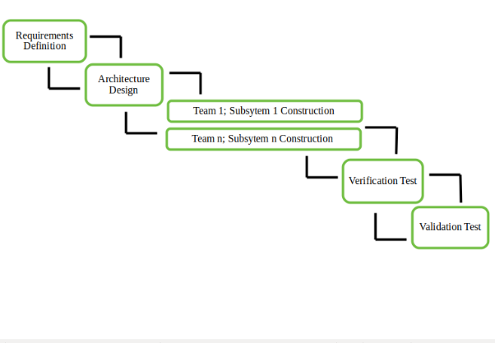

Figure : Sample Picture

We would be using Incremental model for this project. An incremental model is a continuous module development software development life-cycle model in which the requirements comes as is and its development starts without waiting for other requirements to complete.

### **Rationale behind Selected Methodology**

Object-oriented programming approach is selected for this project as it is developed using *Java* and *php* that are best tools for executing object-oriented programming concept. Another reason is for its ability to provide the functionality of developing easy to manage, interchangeable separate modules that are called and executed only when needed. Thus, fulfilling the aim of a fast system.

# **Problem** **Definition**

## **Problem** **Statement**

People encourage technology to replace every action with modern, fast and efficient computerized methods. Hence technology evolves as the day passes. Applying automated systems to every problem possible is now a Milestone to become a first world country or Nation.

This leads to the problem for the people living in a community. Community’s administrations provide certain services to the people living in the community. These services include shopping malls and multiple everyday services i.e. plumber, electrician, gardener, mechanic etc. Availing and enjoying these services manually is a costly process in terms of time and budget as well. To cope with the modern world, it is a dire need to have a single computerized system that provides above mentioned services while working under the roof of community and at the distance of a few clicks.

## **Deliverables and Development Requirements**

### **Deliverables**

#### **Cross-platform Application**

As the solution of the problem, explained before, it is a deliverable combining portals which are part of the cross-platform (Android + Web) application. All these portals will allow users to fulfil their needs using android or web/windows dependent hardware gadgets i.e. Android smartphone or PC etc. This cross-platform application will use MySQL based server which will act as central database for the entire application. It will store the record/data which will be retrieved and processed as per requirement. Following are the parts/different modules of the cross-platform application.

* Reserving
* Shopping
* Service Hiring
* Billing
* Complaints

#### **Reports**

It will act as complete Project Report which will include Software Requirements Specification Document, Software Design Specification Document, GUI Mock-ups etc. It will also include detailed description about how to use the application (User Manual) and how testing is accomplished for the application after development.

### **Development Requirements**

Following are the requirements which the developing team must have in order to develop the complete system.

#### **OS Requirements**

Any OS, which above mentioned hardware machine can work with, will be enough to fulfil the requirement. In this case windows/ Mac or any other operating system, Higher than or equal to Windows 7 in power, will be sufficient.

#### **Hardware Requirements**

For development purpose, minimum hardware requirement is of a machine that has enough power to execute required IDE’s efficiently i.e. a hardware machine that, in term of power, is equal to or higher than standard Dell core-i3 machines.

#### **Application Requirements**

To meet development requirements, applications such as; Android studio, SQL server management studio, Visual Studio Code are used.

#### **Other Requirements**

For Mock-up, presentation and documentation purpose we use MS-Office and Adobe Photoshop CS6. For designing and modelling different scenarios we use various modelling techniques and tools like Star UML and Visual Paradigm.

## **Current System**

The services which will be provided by this application can be found as different websites and applications, developed for general public, scattered all around the World Wide Web. A couple of such applications and websites are; Amazon and Pakistan Citizen Portal.

### **Amazon**

This website (along with its android application) is known in the world for online shopping. User surfs through the website to select things that he/she wants to buy. When found, he/she selects online/cash on delivery method for payment. Then user has to wait a couple of days to have that item delivered to his house.

### **Pakistan Citizen Portal**

It is a government android app that allows public to put complaints regarding the working of any governmental institute.

# **Requirements Analysis**

## **Use Cases Diagram(s)**

A use case diagram is a graphical representation of the interaction between user and the software system. It shows the relationship between the user and different use cases (actions) provided by the system. It also describes the dependency among use cases. A user can be a person or another system. A use case diagram is composed of four elements,

* Container
* Use case
* Actor
* Association

### **Sign Up**

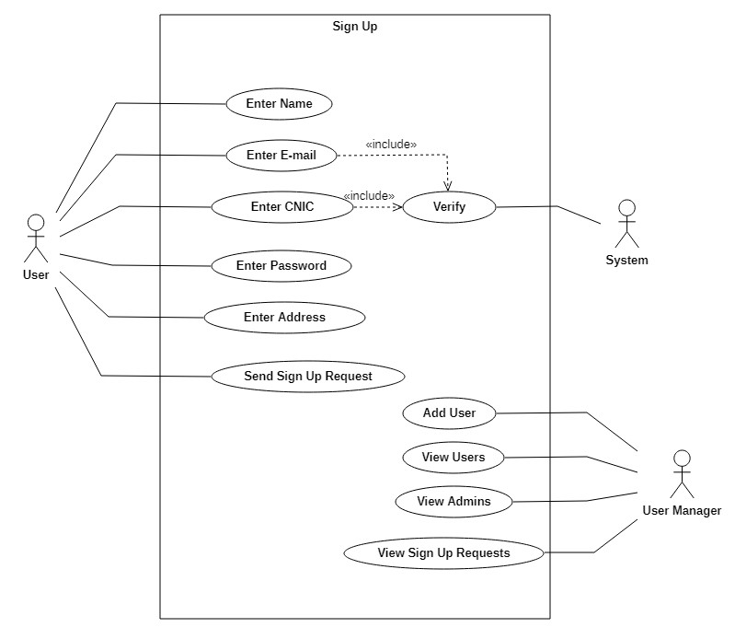

Figure : Sign Up Use Case Diagram

### **Shop**

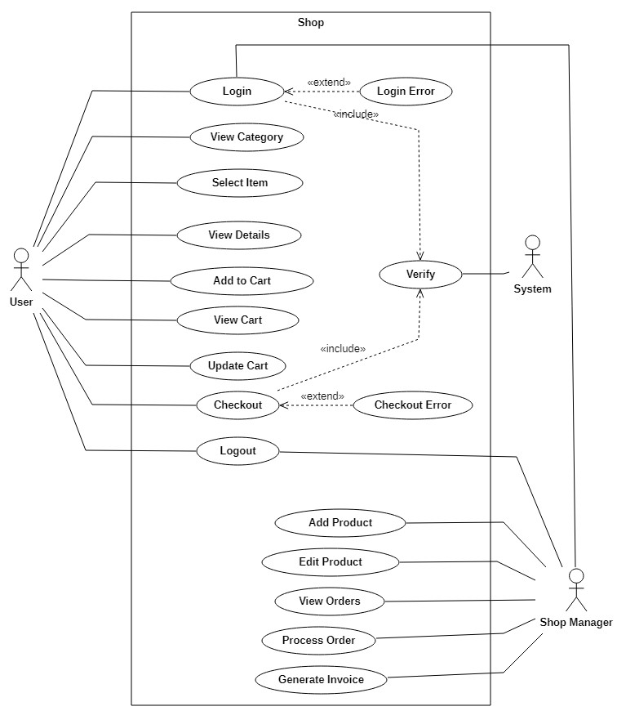

Figure : Shop Use case Diagram

### **BookIt**

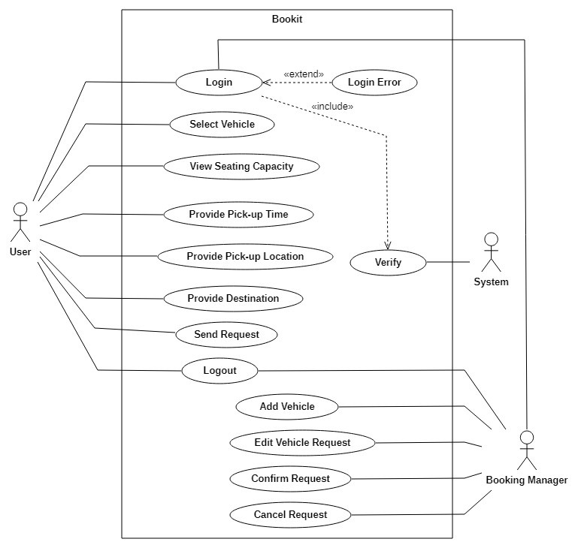

Figure : BookIt Use case Diagram

### **Hire Service**

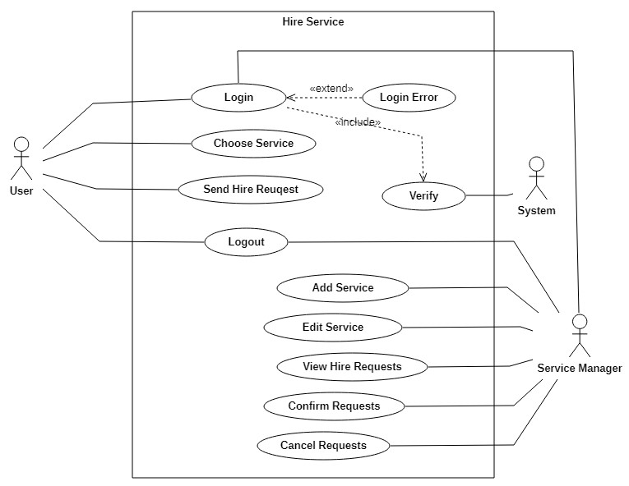

Figure : Hire Service Use Case

### **Pay Bills**

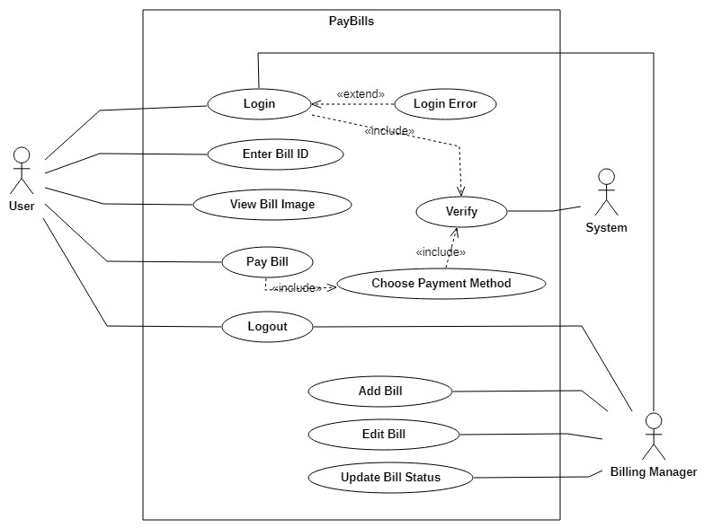

Figure : Billing Use Case Diagram

Figure : Complain Use Case Diagram

## **Detailed Use Case**

### **Signing Up**

|  |  |
| --- | --- |
| **Use case name** | **Enter Name** |
| **Actor** | User |
| **Description** | User provides his/her name in the text field. |
| **Pre-condition** | User must not be registered. |
| **Post-condition** | Nil |
| **Extend** | Nil |
| **Normal flow** | 1. Go to Home page of website/Open App. 2. Click on sign up button. 3. Fill Enter Name Field. |

Table : Enter Name Use Case (Signing Up)

|  |  |
| --- | --- |
| **Use case name** | **Enter Email** |
| **Actor** | User |
| **Description** | User provides his/her email in the text field. |
| **Pre-condition** | User must not be registered using this email. |
| **Post-condition** | Nil |
| **Extend** | Nil |
| **Normal flow** | 1. Go to Home page of website/Open App. 2. Click on sign up button. 3. Fill Enter Email Field. |

Table : Enter Email Use Case (Signing Up)

|  |  |
| --- | --- |
| **Use case name** | **Enter Password** |
| **Actor** | User |
| **Description** | User provides apassword in the text field. |
| **Pre-condition** | User must not be registered and password must contain alphabets, numbers and special characters. |
| **Post-condition** | Nil |
| **Extend** | Nil |
| **Normal flow** | 1. Go to Home page of website/Open App. 2. Click on sign up button. 3. Fill Enter Password Field. |

Table : Enter Password Use Case (Signing Up)

|  |  |
| --- | --- |
| **Use case name** | **Confirm Password** |
| **Actor** | User |
| **Description** | User provides apassword in the text field. |
| **Pre-condition** | User must not be registered and must have entered password. |
| **Post-condition** | Nil |
| **Extend** | Nil |
| **Normal flow** | 1. Go to Home page of website/Open App. 2. Click on sign up button. 3. Fill Confirm Password Field. |

Table : Confirm Password Use Case (Signing Up)

|  |  |
| --- | --- |
| **Use case name** | **Create Account** |
| **Actor** | User |
| **Description** | User presses create account button to register. |
| **Pre-condition** | User must not be registered before, must have filled all the fields and password must be confirmed. |
| **Post-condition** | Nil |
| **Extend** | Nil |
| **Normal flow** | 1. Go to Home page of website/Open App. 2. Click on sign up button. 3. Fill Credentials. 4. Click/Press on Create Account button. |

Table : Create Account Use Case (Signing Up)

|  |  |
| --- | --- |
| **Use case name** | **Verify** |
| **Actor** | System |
| **Description** | System verifies user’s email and confirms password. |
| **Pre-condition** | User must provide email and fill enter password and confirm password fields. |
| **Post-condition** | User must click/press Create Account button. |
| **Extend** | Nil |
| **Normal flow** | 1. Go to Home page of website/Open App. 2. Click on sign up button. 3. Fill Credentials. 4. Click/Press on Create Account button. |

Table : Verify Use Case (Signing Up)

### **Online Shopping**

|  |  |
| --- | --- |
| **Use case name** | **Login** |
| **Actor** | User |
| **Description** | User provides email address and password and clicks on login button. |
| **Pre-condition** | User must be registered and must fill all the required credentials. |
| **Post-condition** | Nil |
| **Extend** | Login Error |
| **Normal flow** | 1. Open App/Website. 2. Click on Login button. 3. Fill all the credentials. 4. Click/Press on Login button. |

Table : Login Use Case (Online Shopping)

|  |  |
| --- | --- |
| **Use case name** | **View Details** |
| **Actor** | User |
| **Description** | User selects an item to view its details. |
| **Pre-condition** | User must be logged in and have selected a category. |
| **Post-condition** | Nil |
| **Extend** | Nil |
| **Normal flow** | 1. Open App/Website. 2. Fill Credentials for Login. 3. Press on Login Button. 4. Choose Shop Category from Home Page. 5. Select Item Category. 6. Select an item. |

Table : View Details Use Case (Online Shopping)

|  |  |
| --- | --- |
| **Use case name** | **Add to Cart** |
| **Actor** | User |
| **Description** | User selects an item and press on add to cart button. |
| **Pre-condition** | User must be logged in, must have selected a category and item. |
| **Post-condition** | Nil |
| **Extend** | Nil |
| **Normal flow** | 1. Open App/Website. 2. Fill Credentials for Login. 3. Press on Login Button. 4. Choose Shop Category from Home Page. 5. Select Item Category. 6. Select an item. 7. Press Add to Cart button. |

Table : Add to Cart Use Case (Online Shopping)

|  |  |
| --- | --- |
| **Use case name** | **Checkout** |
| **Actor** | User |
| **Description** | User checkouts to buy the items added in the cart. |
| **Pre-condition** | User must be logged in, must have selected a category, item and added it to cart. |
| **Post-condition** | Nil. |
| **Extend** | Checkout Error. |
| **Normal flow** | 1. Open App/Website. 2. Fill Credentials for Login. 3. Press on Login Button. 4. Choose Shop Category from Home Page. 5. Select Item Category. 6. Select an item. 7. Press Add to Cart button. 8. Press View Cart Button. 9. Press Checkout. |

Table : Checkout Use Case (Online Shopping)

|  |  |
| --- | --- |
| **Use case name** | **Logout** |
| **Actor** | User |
| **Description** | User selects logout button to Log out from app/website. |
| **Pre-condition** | User must be logged in. |
| **Post-condition** | Nil |
| **Extend** | Nil |
| **Normal flow** | 1. Go to Home page of website/Open App. 2. Click on Login button. 3. Fill all the credentials. 4. Click/Press on Login button. 5. Click on Logout Button to leave Home Page/website. |

Table : Logout Use Case (Online Shopping)

|  |  |
| --- | --- |
| **Use case name** | **View Order** |
| **Actor** | Shop Manager |
| **Description** | Shop Manager views the placed orders list from order queue. |
| **Pre-condition** | Shop Manager must be logged in to Shop portal. |
| **Post-condition** | Nil |
| **Extend** | Nil |
| **Normal flow** | 1. Open web portal of management end. 2. Click on Login to Shop button. 3. Fill all the credentials. 4. Click/Press on Login button. 5. Click on View Orders List button. |

Table : View Order Use Case (Online Shopping)

|  |  |
| --- | --- |
| **Use case name** | **Generate Invoice** |
| **Actor** | Shop Manager |
| **Description** | Shop Manager generates invoice. |
| **Pre-condition** | Shop Manager must be logged in to Shop portal and have order. |
| **Post-condition** | Nil |
| **Extend** | Nil |
| **Normal flow** | 1. Open web portal of management end. 2. Click on Login to Shop button. 3. Fill all the credentials. 4. Click/Press on Login button. 5. Click on View Orders Queue button. 6. Select an Order. 7. Click on Generate Invoice button. |

Table : Generate Invoice Use Case (Online Shopping)

|  |  |
| --- | --- |
| **Use case name** | **Verify** |
| **Actor** | System |
| **Description** | System verifies the login credentials. |
| **Pre-condition** | Login credentials must be all be filled. |
| **Post-condition** | Nil |
| **Extend** | Nil |

Table : Verify Use Case (Online Shopping)

### **Online Service Hiring**

|  |  |
| --- | --- |
| **Use case name** | **Select Service** |
| **Actor** | User |
| **Description** | User selects a service for hiring. |
| **Pre-condition** | User must be logged in and have selected a Service Type. |
| **Post-condition** | Nil |
| **Extend** | Nil |
| **Normal flow** | 1. Open App/Website. 2. Fill Credentials for Login. 3. Press on Login Button. 4. Choose Hire Service Category from Home Page. 5. Select Service Type. 6. Click on any of the provided services. |

Table : Select Service Use Case (Online Service Hiring)

|  |  |
| --- | --- |
| **Use case name** | **Send Hire Request** |
| **Actor** | User |
| **Description** | User selects a service and press hire service button to send request to management. |
| **Pre-condition** | User must be logged in and must have selected a Service Type. |
| **Post-condition** | Nil |
| **Extend** | Nil |
| **Normal flow** | 1. Open App/Website. 2. Fill Credentials for Login. 3. Press on Login Button. 4. Choose Hire Service Category from Home Page. 5. Select Service Type. 6. Click on any of the provided services. 7. Press on Hire Service Button to send hire request to management. |

Table : Send Hire Request Use Case (Online Service Hiring)

|  |  |
| --- | --- |
| **Use case name** | **View Request** |
| **Actor** | Service Manager |
| **Description** | Service Manager views the hiring request from hiring request list. |
| **Pre-condition** | Service Manager must be logged in to Hire Request portal. |
| **Post-condition** | Nil |
| **Extend** | Nil |
| **Normal flow** | 1. Open web portal of management end. 2. Click on Login to Hire Service button. 3. Fill all the credentials. 4. Click/Press on Login button. 5. Click on View Hiring Request button. |

Table : View Request Use Case (Online Service Hiring)

|  |  |
| --- | --- |
| **Use case name** | **Cancel Request** |
| **Actor** | Service Manager |
| **Description** | Service Manager cancels the hiring request from hiring request list after confirming non-availability of Serviceman. |
| **Pre-condition** | Manager must be logged in to Hire Request portal and must have opened an incoming request. |
| **Post-condition** | Nil |
| **Extend** | Nil |
| **Normal flow** | 1. Open web portal of management end. 2. Click on Login to Hire Service button. 3. Fill all the credentials. 4. Click/Press on Login button. 5. Click on View Hire Request List button. 6. Click on Cancel Request Button. |

Table : Cancel Request Use Case (Online Service Hiring)

|  |  |
| --- | --- |
| **Use case name** | **Verify** |
| **Actor** | System |
| **Description** | System verifies the login credentials. |
| **Pre-condition** | Login credentials must be all be filled. |
| **Post-condition** | Nil |
| **Extend** | Nil |

Table : Verify Use Case (Online Service Hiring)

### **Online Billing**

|  |  |
| --- | --- |
| **Use case name** | **Enter Bill ID** |
| **Actor** | User |
| **Description** | User can enter bill ID. |
| **Pre-condition** | User must be logged in. |
| **Post-condition** | Bill ID must be correct. |
| **Extend** | Nil |
| **Normal flow** | 1. Login to Website/application 2. Click on “Billing” Control. 3. Choose bill type. 4. Enter Bill ID |

Table : Enter Bill ID Use Case (Online Billing)

|  |  |
| --- | --- |
| **Use case name** | **View Details** |
| **Actor** | User |
| **Description** | User clicks and chooses to view details of the Bill. |
| **Pre-condition** | User must be logged in. |
| **Post-condition** | Nil |
| **Extend** | Nil |
| **Normal flow** | 1. Login to Website/application 2. Click on “Billing” Control. 3. Choose bill type. 4. Enter Bill ID. 5. User clicks on View details. |

Table : View Details Use Case (Online Billing)

|  |  |
| --- | --- |
| **Use case name** | **Pay Bill** |
| **Actor** | User |
| **Description** | User can select pay bill to pay the bills. |
| **Pre-condition** | User must select a bill of specific type.  User Must be Logged In. |
| **Post-condition** | Bill payment Must be paid. |
| **Extend** | Nil |
| **Normal flow** | 1. Login to Website/application 2. Click on “Billing” Control. 3. Choose bill type. 4. Enter Bill ID. 5. User clicks to pay Bill. |

Table : Pay Bill Use Case (Online Billing)

|  |  |
| --- | --- |
| **Use case name** | **Add New Bill** |
| **Actor** | Billing Manager |
| **Description** | Billing Manager can add a new bill to database. |
| **Pre-condition** | Billing Manager must be logged in to billing portal. |
| **Post-condition** | Record must be added successfully. |
| **Extend** | Nil |
| **Normal flow** | 1. Manager selects Add new Bill option. 2. Manager adds the required data and submit to data base. |

Table : Add New Bill Use Case (Online Billing)

### **Online Booking**

|  |  |
| --- | --- |
| **Use case name** | **Select Vehicle** |
| **Actor** | User |
| **Description** | User can choose a vehicle of choice from different choices. |
| **Pre-condition** | User must be logged in. |
| **Post-condition** | Nil |
| **Extend** | Nil |
| **Normal flow** | 1. Login to Website/application 2. Choose Car. |

Table : Select Vehicle Use Case (Online Booking)

|  |  |
| --- | --- |
| **Use case name** | **Confirm timings and Destination** |
| **Actor** | User |
| **Description** | User can confirm Timings and Destination. |
| **Pre-condition** | User must be logged in.  User must have selected any service. |
| **Post-condition** | Nil |
| **Extend** | Nil |
| **Normal flow** | 1. Login to Website/application 2. Click on “Book” Control. 3. Set Timings and Destination. |

Table : Confirm timings and Destination Use Case (Online Booking)

|  |  |
| --- | --- |
| **Use case name** | **Reserve Car** |
| **Actor** | User |
| **Description** | User can confirm reservation of car. |
| **Pre-condition** | User must be logged in.  User must have selected a car. |
| **Post-condition** | Reservation must be confirmed. |
| **Extend** | Nil |
| **Normal flow** | 1. Login to Website/application 2. Click on “Book” Control. 3. Choose Vehicle. 4. Confirm timings and Destination. 5. Confirm reservation. |

Table : Reserve Car Use Case (Online Booking)

|  |  |
| --- | --- |
| **Use case name** | **View Reservations** |
| **Actor** | Booking Manager |
| **Description** | Booking Manager can choose to view Reservation Requests of the user. |
| **Pre-condition** | There must be a Vehicle requested to be reserved by the user. |
| **Post-condition** | Nil |
| **Extend** | Nil |
| **Normal flow** | 1. Manager selects view reservation list Control. 2. Manager Views Reservations. |

Table : View Reservations Use Case (Online Booking)

|  |  |
| --- | --- |
| **Use case name** | **Confirm Request** |
| **Actor** | Booking Manager |
| **Description** | Booking Manager chooses to confirm Request. |
| **Pre-condition** | User has put up a reservation request. |
| **Post-condition** | Nil |
| **Extend** | Nil |
| **Normal flow** | 1. Manager selects Views Reservation List. 2. Manager confirms request. |

Table : Confirm Request Use Case (Online Booking)

### **Online Complain**

|  |  |
| --- | --- |
| **Use case name** | **Define Subject** |
| **Actor** | User |
| **Description** | User can define subject, indication of the topic, of the complaint. |
| **Pre-condition** | User must be logged in.  User must choose complaint category. |
| **Post-condition** | Nil |
| **Extend** | Nil |
| **Normal flow** | 1. Login to Website/application 2. Click on “Complaint” Control. 3. Choose category of complaint. 4. Define Subject. |

Table : Define Subject Use Case (Online Complain)

|  |  |
| --- | --- |
| **Use case name** | **Write Complaint** |
| **Actor** | User |
| **Description** | User can type actual complaint description here. |
| **Pre-condition** | User must be logged in.  Subject is Defined. |
| **Post-condition** | Complaint must be written in understandable way. |
| **Extend** | Nil |
| **Normal flow** | 1. Login to Website/application 2. Click on “Complaint” control. 3. Choose Category of complaint. 4. Define Subject. 5. Explain/Describe the issue to complain. |

Table : Write Complaint Use Case (Online Complain)

|  |  |
| --- | --- |
| **Use case name** | **Send Request** |
| **Actor** | User |
| **Description** | User can send request. |
| **Pre-condition** | User must be logged in. User has selected to put complaint. Subject of complaint is defined. |
| **Post-condition** | Request submitted confirmation. |
| **Extend** | Nil |
| **Normal flow** | 1. Login to Website/application 2. Click on “Complaint” control. 3. Write complaint 4. Send complaint. |

Table : Send Request Use Case (Online Complain)

## **Requirements**

A complete description of what the software system will do without describing how it will do is represented by the software requirements. A condition or capability that must be met or possessed by a system to satisfy a contract, standard, specification or other formally imposed documents.

### **Functional requirements**

Following are the functional requirements of *Community Service Provider*,

#### **Sign Up**

The functional requirement of Sign Up module are as follows,

* FR-1: *User shall be able to enter his/her Full Name.*
* FR-2: *User shall be able to provide his/her Email.*
* FR-3: *User shall be able to provide CNIC.*
* FR-4: *User shall be able to provide Block No.*
* FR-5: *User shall be able to provide Street No.*
* FR-6: *User shall be able to provide House No.*
* FR-7: *User shall be able to provide Contact No.*
* FR-8: *User shall be able to provide password.*
* FR-9: *User shall be enabled to match/confirm password.*
* FR-10: *System shall confirm email and password.*

#### **Shop**

The functional requirements of Shop module are as follows,

* FR-11: *User shall be able to select product category of his/her choice.*
* FR-12: *User shall be able to view items.*
* FR-13: *User shall be able to search items.*
* FR-14*: User shall be able to add or remove items from Cart.*
* FR-15: *User shall be able to checkout and choose payment method of his/her choice.*
* FR-16: *Manager shall be able to Generate Invoice for an order..*
* FR-17: *Manager shall be able to add a New Item or update and Existing Item..*

#### **BookIt**

The functional requirements of Reserve a ride module are as follows,

* FR-18: *User shall be able to rent a vehicle of his/her choice from the available ones.*
* FR-19: *Manager shall be able to View Reservation Requests.*
* FR-20: *Manager shall be able to Cancel Reservation Request.*
* FR-21: *System shall be able to verify User Verification Credentials.*

#### **Hire Service**

The functional requirements of Hire Service module are as follows,

* FR-22: *User shall be able to select a service of his/her choice.*
* FR-23: *User shall be able to View the Serviceman Profiles.*
* FR-24: *User shall be able to Send Hiring Request to management.*
* FR-25: *Manager shall be able to view Hiring Requests.*
* FR-26: *Manager shall be able to Confirm or Cancel Hiring Request on the basis of Servicemen Availability.*
* FR-27: *System shall be able to verify User verification credentials.*

#### **Complain**

The functional requirements of Complain module are as follows,

* FR-28: *User shall be able to go to complaints portal from main application/website.*
* FR-29: *User shall be able to select type/category of the complaint.*
* FR-30: *User shall be able to describe the purpose/incident of complaint.*
* FR-31: *User shall be able to send complaint.*
* FR-32: *User shall be able to logout from application.*
* FR-33: *System shall receive complaints put by users/residents of the community.*
* FR-34: *Manager shall be able to view complaints.*
* FR-35: *Manager shall be able to send confirmation to user.*
* FR-36: *Manager shall be able to change status of complaint.*

#### **Pay Bills**

The functional requirements of Pay Bills module are as follows,

* FR-37: *User shall be able to go to bill payment portal from main application.*
* FR-38: *User shall be able to enter bill Id to fetch details of the bill from the record.*
* FR-39: *User shall be provided with the image of the bill displaying all the details.*
* FR-40: *User shall be notified with the status of the bill.*
* FR-41: *If status is “not paid”, user shall be enabled to pay bill by asking credit card transaction details.*
* FR-42: *As the user enters the credit card credentials, user shall be able to pay the bill by clicking on “pay now” control.*
* FR-43: *As the user pays the bill, bill status shall be updated to “paid”.*
* FR-44: *Manger shall be able to view bill record.*
* FR-45: *Manager shall be able to add bill record.*
* FR-46: *Manager shall be able to update record.*

### **Non-functional requirements**

These requirements specify the criteria that can be used to judge the operation of a system.

rather than specific behavior. It ensures the quality of a software. It essentially specifies how

the system should behave and the constraints upon the system.

#### **NFR-1: Security requirement**

Safety is essential for a software system. Non-community members cannot access the services. Safety

requirement is maintained through providing unique Verification ID allotted to each residence of the Community.

#### **NFR-2: Reliability**

User can undoubtedly give their data it’s secure application.

#### **NFR-3: Maintainability**

Errors can be easily handled. In future if anyone want to modify it, the changes can easily be accommodated.

#### **NFR-4: Reusability**

The modules of the system can be used at anywhere. Code and design can also be reused to extend this project in the future. The web panel is made using PHP and Bootstrap4 etc. which are platform independent and can be transported to Other servers with minimum effort.

#### **NFR-5: Performance**

*Community Service Provider* Application and Website has the ability to handle workload without creating issues that disrupting its working.

#### **NFR-6: Usability**

*Community Service Provider* website, android application and web portal has an easy to understand and effortless UI which makes the user experience of getting services faster and convenient.

#### **NFR-7: Portability**

The website can be accessed on Mac, Linux as well as on Windows and on the other hand, the android app can be accessed at any android device.

# **Design and Architecture**

## **System Architecture**

### **Flow chart Diagram**

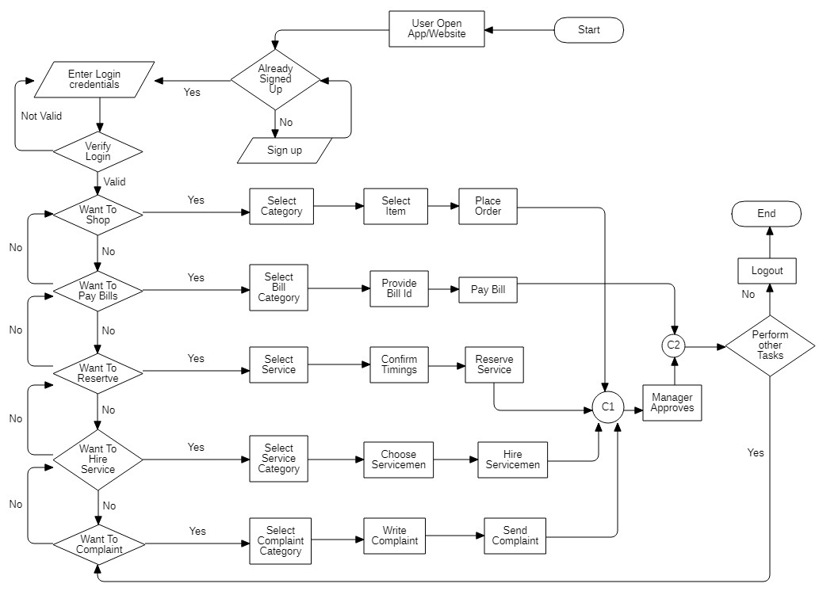

Figure : Flow Chart

### **Description:**

Above flow chart diagram Explains the basic flow of the Community Service Provider. User starts interaction by opening the application or website. User signs up in case he has not already signed up. After signing up user provide login credentials. If the credentials are valid then user gets access to the main/home page of the application/website.

Once the user is inside the main page, he/she can choose to shop, reserve, hire service, put complaint, or pay bills using the controls.

In shopping category, user selects category of the items to shop and selects Item. After that user places the order which is further processed by manager to perform managerial tasks and the task is completed. Later user can select to perform other tasks or exit. Similarly, in billing user is enabled to select bill category, provide bill id and pay bill and then may select to exit or perform another task. For reservation, user selects service, confirms timing and reserves the service, which is renting/booking a car for travel purpose. For hiring service, user selects service category, choose servicemen and hire them. after this, user can either select other tasks or exits using logout control. At last user can put complaint regarding any misbehavior or misconduct of servicemen or other residents as well as issues in community services. User has to select category, write complaint and send it.

## **Data Representation**

### **Data Flow Diagram (level 0)**

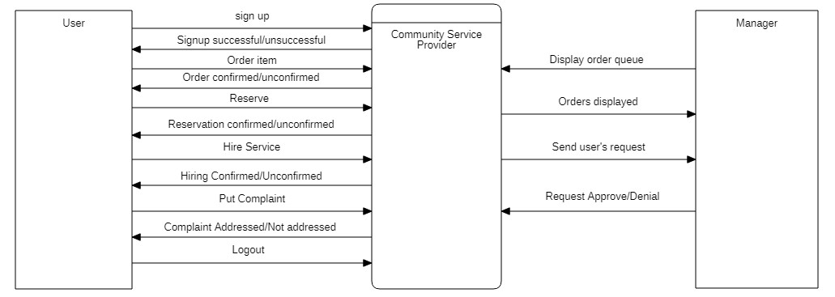

Figure : Data Flow Diagram (Level 0)

**Description:**

The above diagram shows the overall implementation and high-level data flow of the system. A large set of data flows from

* User towards System when the user registers, place orders, reserves a car, make requests for hire services, pay bills and put complaints.
* Manager towards System when the system inputs Manager’s queries such as view order queue, generate invoice, send invoice, confirm service hiring etc.
* System towards Manager when the system outputs user’s placed orders, responses to reservation requests, service hiring requests etc.

### **Data Flow Diagram (level 1)**

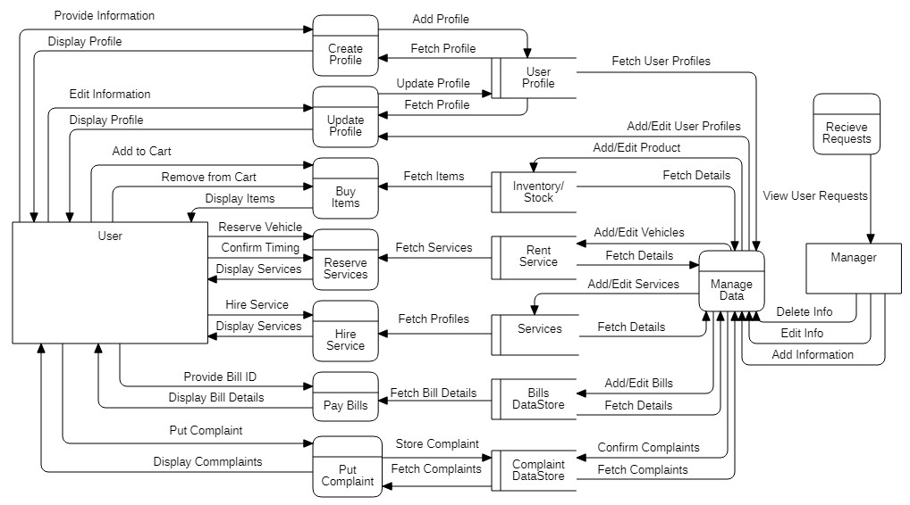

Figure : Data Flow Diagram (Level 1)

**Description:**

Above diagram is level-1 data flow diagram of Community Service Provider. Data in this application, at this level of abstraction, flows as User;

* Provide information to create account, later user’s data is stored into database.
* Add or removes items from cart, later data is stored and updated in database table.
* Provide details to reserve/rent a vehicle and later if available, confirmation is sent to the user.
* Provide details to hire services and if available confirmation response is sent to the user.
* Provide bill ID to view/fetch details of the bill.
* Provide bill ID to pay the amount of the bill.
* Meanwhile in the back-end bill data store or table in database is constantly used to store and retrieve data.
* Put complaint against any illegal activity or any other issue, along with it, under the curtain, complaint table is used to store and retrieve data.

The Manager also plays his role in data flow as he manages data of all the data stores or tables and when user requests of some action which is dependent upon managerial approval, disapproval or any other action.

### **Data Flow Diagram (level 2)**

#### **Online Shopping**

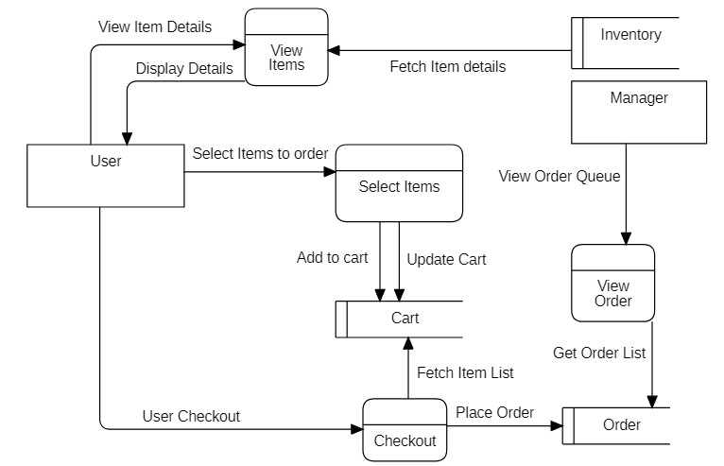

Figure : Online Shopping DFD (Level 2)

**Description:**

The above diagram describes the data flow within the Shopping module. Here data flows from,

* User to System when user commands for viewing details of an item, select items to buy and add it to cart, checkouts.
* Manager to System when manager commands for viewing order lists, adding new items, updating items, adding or updating categories of the items.
* System to Database when system adds items to cart table. Updates cart table, place user’s orders in orders table.
* Database to System when the responses for fetching item details and lists, order lists are generated.
* System to User and Manager when system displays details to the respective users and redirect to different pages.

#### **Online Booking**

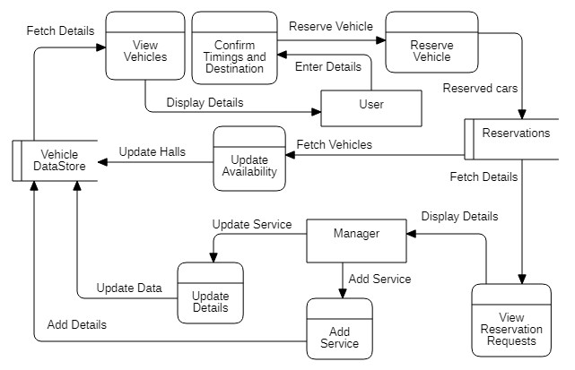

Figure : Online Booking DFD (Level 2)

**Description:**

The above diagram describes the data flow within the Booking module. Here data flows from,

* User to System when user views available vehicles, confirm reservation timings and reserve a vehicle.
* Manager to System when manager adds a car, updates availability and views reservation requests.
* System to Database when system adds reservation details to reservation record tables and further processes it accordingly.
* Database to System when the responses for fetching details are generated and vice versa when system tends to store data/record into database.
* System to User and Manager when system displays available cars details and reserved cars details to both respectively and redirect to different pages.

#### **Online Service Hiring**

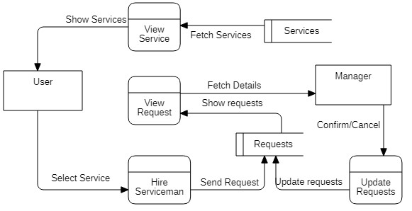

Figure : Online Service Hiring DFD (Level 2)

**Description:**

The above diagram describes the data flow within the Service Hiring module. Here data flows from,

* User to System when user selects a service, send hiring request by clicking a control on the page and confirms hiring a service.
* Manager to System when manager commands for viewing Hiring Request list, approves and cancels hiring requests.
* System to Database when system adds user’s hiring requests to Requests table, updates entities in request table.
* Database to System when the responses for fetching hired Services details.
* System to User and Manager when system displays service details, hiring requests to the respective users and redirect to different pages.

#### **Online Billing**

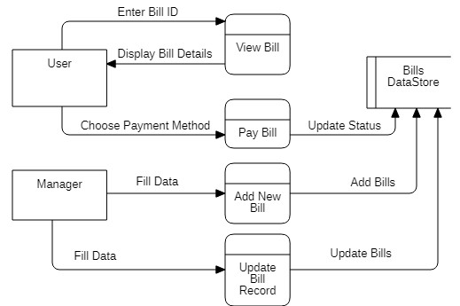

Figure : Online Billing DFD (Level 2)

**Description:**

The above diagram describes the data flow within the Billing module. Here data flows from,

* User to System when user provides bill ID for viewing the bill details presented as image.
* Manager to System when manager adds a new bill, updates existing bill’s record.
* System to Database when system adds or updates bill data in its respective table.
* Database to System when the responses for fetching Bill details are generated.
* System to User and Manager when system displays Bill details to the respective users and redirect to different pages.

#### **Online Complain**

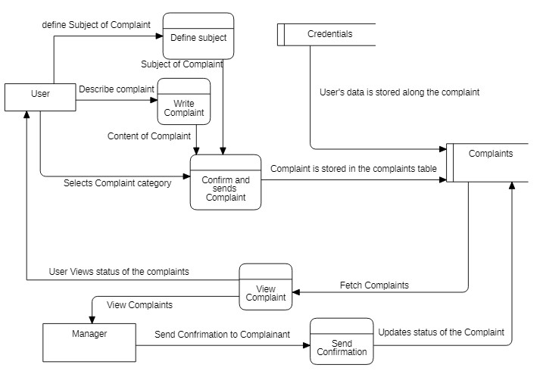

Figure : Online Complain DFD (Level 2)

**Description:**

The above diagram describes the data flow within the Complaint module. Here data flows from,

* User to System when user selects a Complain Type, defines its subject and writes/describes complaint and views the complaint status.
* Manager to System when manager commands for viewing Complaints, confirms complaints, updates status of complaints.
* System to Database when system adds user’s credentials along with the complaint details into complaints table.
* Database to System when the responses for fetching unconfirmed complaints details, confirmed complaint details are generated.
* System to User and Manager when system displays details of complaint of any sort to the respective users and redirect to different pages.

## **Process Flow/Description**

### **Activity Diagram**

#### **User-end**

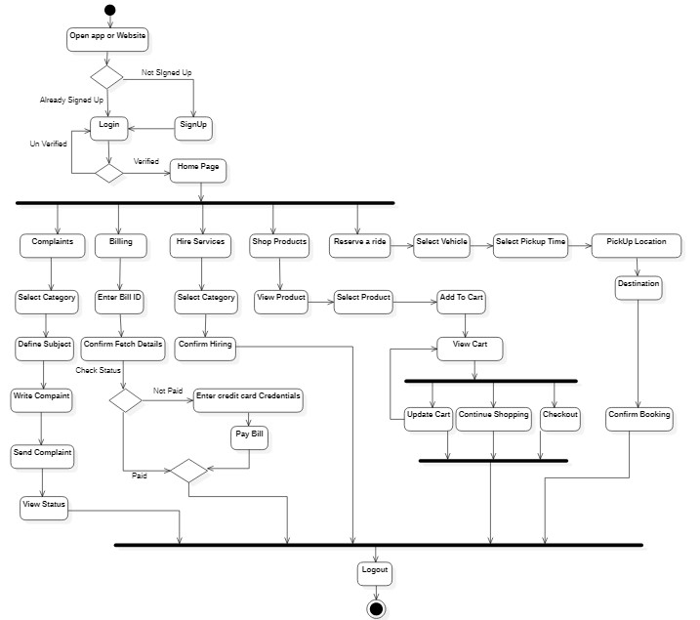

Figure : Activity Diagram (User-End)

**Description:**

The above activity diagram describes the complete flow of user interaction with the system. At first, the user opens the app or website and can either sign up or login. If a user is a new user and does not have an account, he/she is required to Sign Up first. Then the user logins and his credentials are verified. If incorrect, the user is reverted to login page. Otherwise, he/she is presented with services like,

* Shop Items: scroll items and select the item to add it to cart, and checkouts.
* Reserve Service: user selects service, confirms reservation timings.
* Hire Service: user selects service type/category, make hire request for a particular service.
* Pay Bills: user chooses bill type, provides bill ID, views details and pay bill.
* Put Complaints: user selects complaint type, defines subject, writes complaint, and send it to the management.

After acquiring the services of choice, the user sign outs from the website or application.

#### **Manager-end**

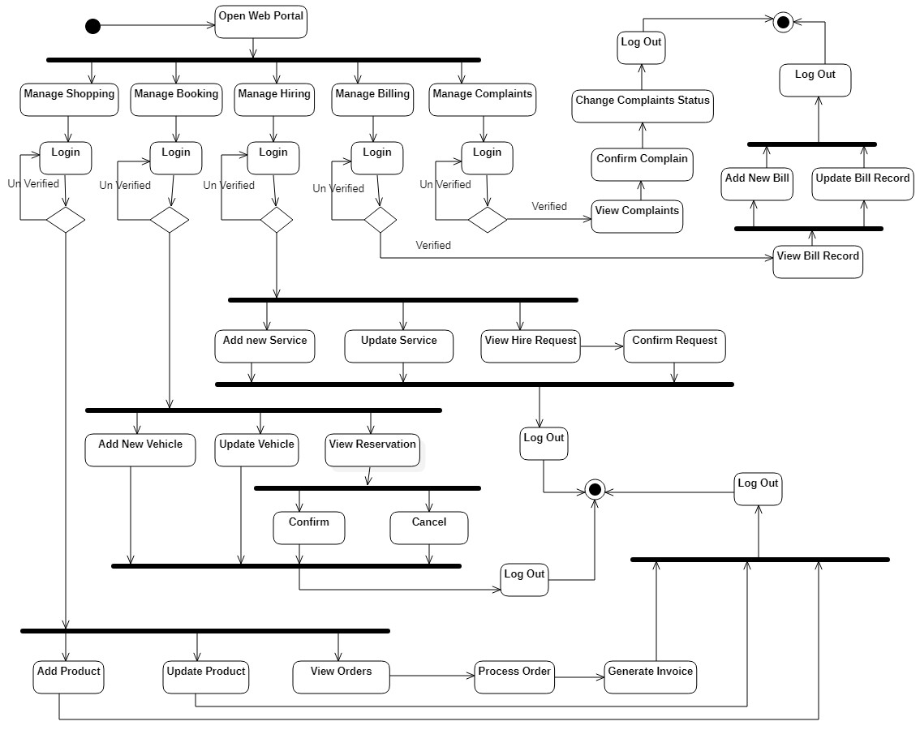

Figure : Activity Diagram (Manager-End)

**Description:**

Above diagram is activity diagram of Manager’s end of the Community Service Provider. Following is its explanation.

Each category of the Community Service Provider is managed by a different person at the management end. This implies separate logins to accommodate encapsulation and good management.

Once a manager login to complaints portal, he can view complaints, send confirmation, change complaint’s status and logout. In billing portal, after login, a manager can view bill record, add new record, update bill record and logout as well. In the portal of managing hiring services, manager can add & update service categories, view & cancel hire request and send confirmation of services hired by the user before logging out. In portal of reservation/booking a ride, manager can view available cars/vehicles, update record, confirm or cancel service request and logout. Manager can add items, update items, add items category, update items category, view order queue, process order, generate invoice of shopping portal and log out of the application.

### **Sequence Diagram**

#### **Signing Up**

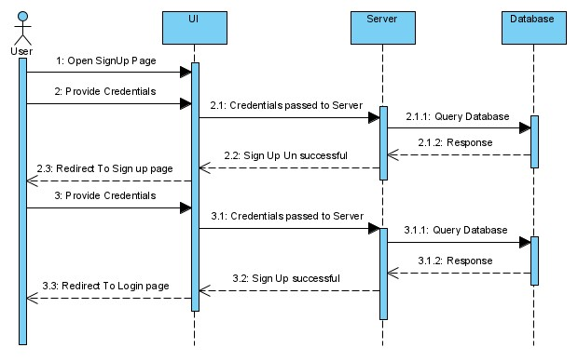

Figure : Sign Up Sequence Diagram

#### **Online Shopping**

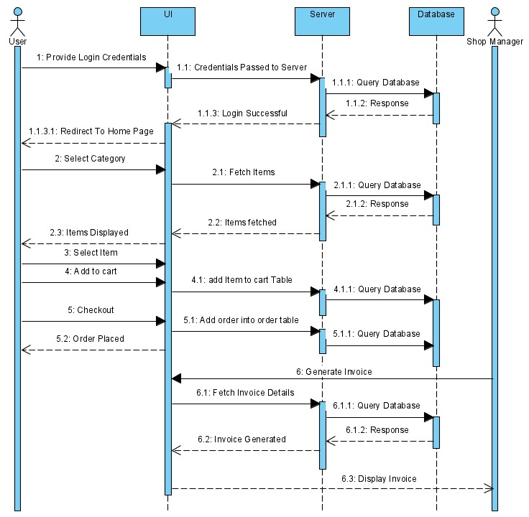

Figure : Online Shopping Sequence Diagram

#### **Online Booking**

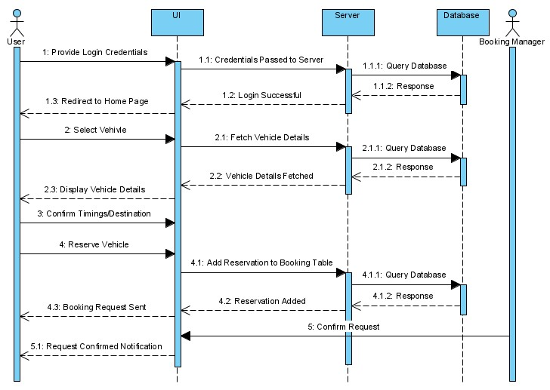

Figure : Online Booking Sequence Diagram

#### **Online Service Hiring**

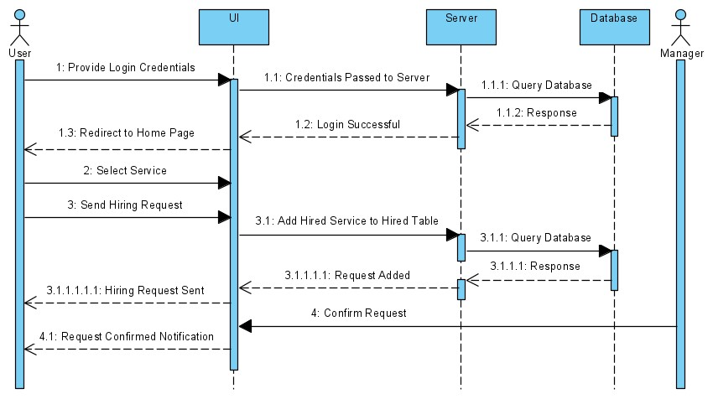

Figure : Online Service Hiring Sequence Diagram

#### **Online Billing**

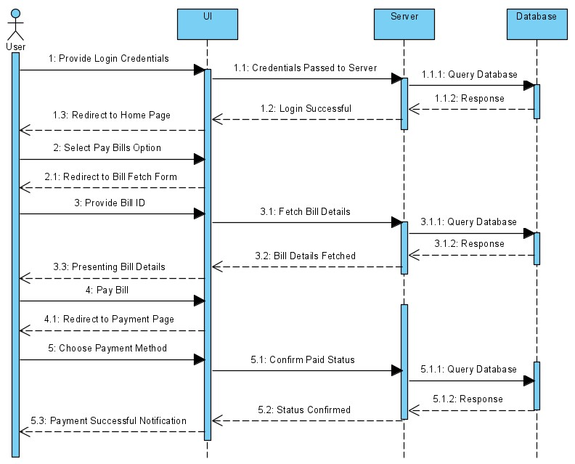

Figure : Online Billing Sequence Diagram

#### **Online Complain**

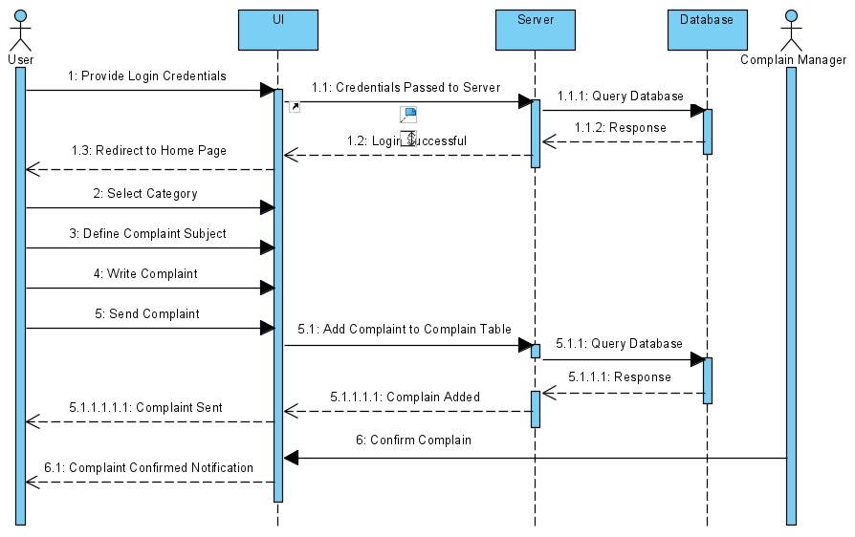

Figure : Online Complain Sequence Diagram

## **Design Models**

### **Entity Relation Diagram**

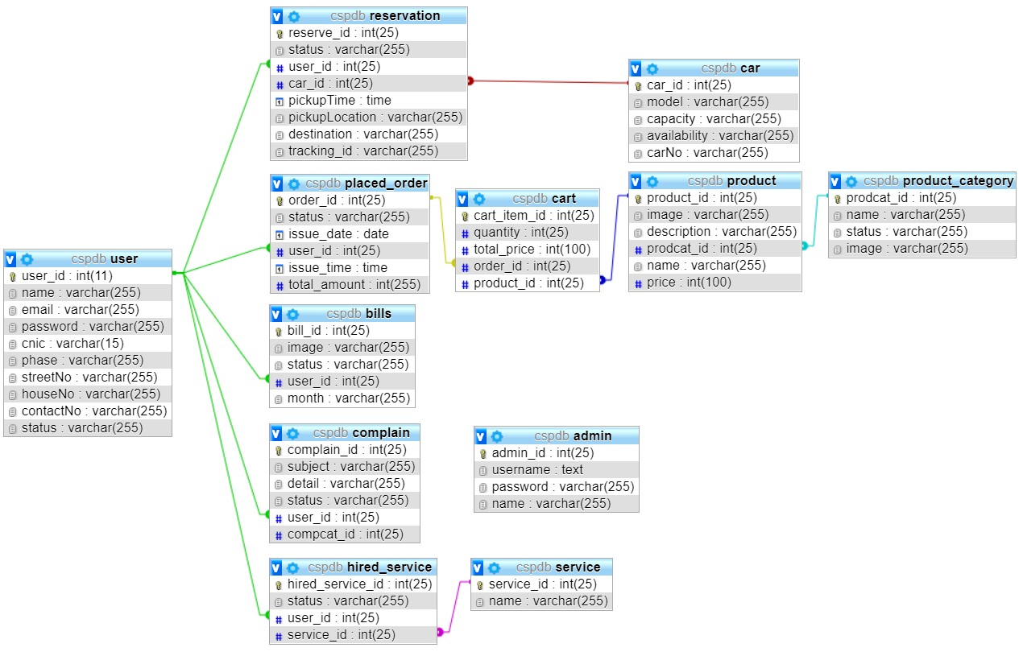

Figure : ERD

# **Implementation**

Implementation is an important part of an SDLC. This stage is a gradual shift from a conceptual design to an actual executable system. This shift is only possible through programming. This stage defines methodology and tools necessary for developing an actual system. For *Community Service Provider*, the methodology and tools are defined as follows,

## **Methodology**

For this project, as discussed earlier, Object-oriented programming approach is adopted. It is a concept of having classes that contains attributes and methods and objects which are representation of those classes.

As for Software Process Model, we would be using Incremental model for this project. An incremental model is a continuous module development software development life-cycle model in which the requirements comes as is and its development starts without waiting for other requirements to complete.

## **Development Stages**

### **Installation of Tools**

#### **Visual Studio Code**

Visual Studio Code is chosen as an IDE for the system. It is a freely available code editor which provides efficient coding experience. It has a wide variety of helpful extensions that help in fast and easy development. Installation of VS Code is the first step of development,

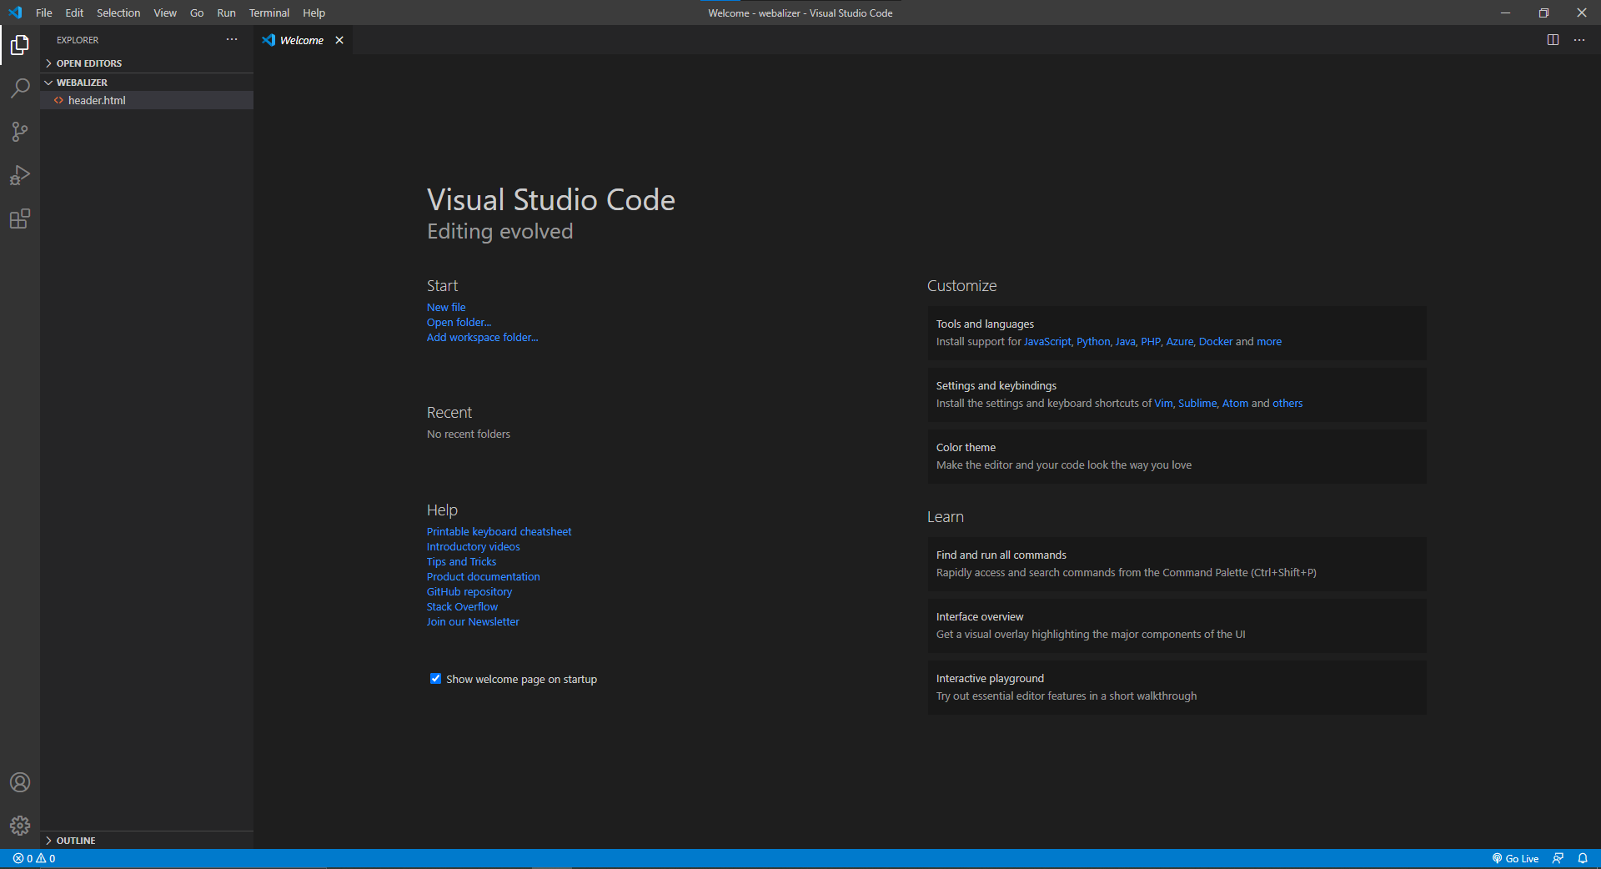

Figure : VS Code

#### **Xampp Server**

Second step of development was to download and install Xampp Server. It is a platform that provides certain configuration settings that make it easy to develop locally. For this project, only two modules; Apache Server and MySQL (phpMyAdmin) is used as a database.

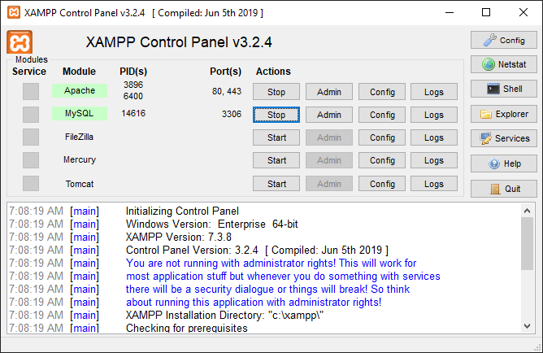

Figure : Xampp Server

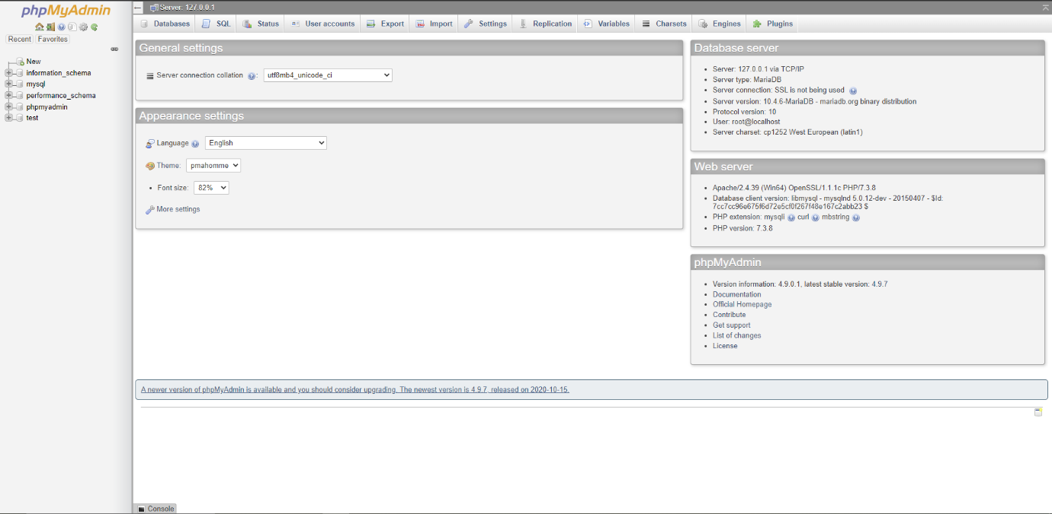

Figure : MySQL (phpMyAdmin)

#### **Android Studio**

In third step, we installed Android Studio; An IDE that facilitates with the fastest tools for developing apps on every type or Android device. This IDE is used for developing the android application of our project,

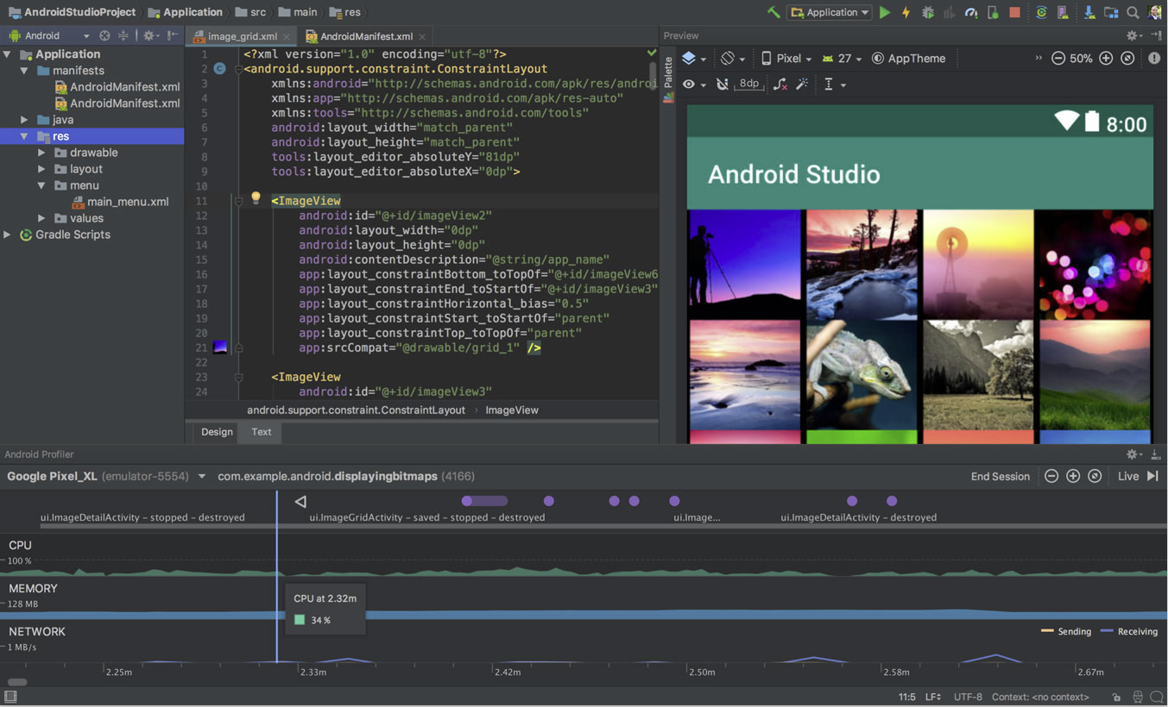

Figure : Android Studio

## **Tools & Technology Used**

|  |  |  |  |
| --- | --- | --- | --- |
| Tools  and  Technologies | **Tools** | **Version** | **Rationale** |
| Visual Studio Code | 1.51.1 | IDE |
| Xampp Server | 3.2.4 | Service Platform |
| MySQL | 4.9.7 | Online Database |
| Android Studio | 4.1.1 | Android app development |
| Adobe Photoshop | 2017 | Interface Design |
| Star UML | 4.0.0 | Diagrams Design |
| MS Word | 365 | Documentation |
| MS Power point | 365 | Presentation |
|  |  |  |
| **Technology** | **Version** | **Rationale** |
| PHP |  | Server End Programming Language |
| Bootstrap 4 | 4.0 | Front end Development Library for Web |
| XML |  | Front End Language for Android |
| Java |  | Back End Programming Language for Android |
| SQL |  | Query Language |

Table : Tools and Technologies

## **User Interface**

### **User End Website**

Community Service Provider Website a simple yet attractive and catchy interface to its users. Each screen is designed in a way to make user’s experience an easy and visually satisfied one. Some of the main screens are shown below,

#### **Login and Signup (Website)**

* A login screen through which user can access the system’s services.

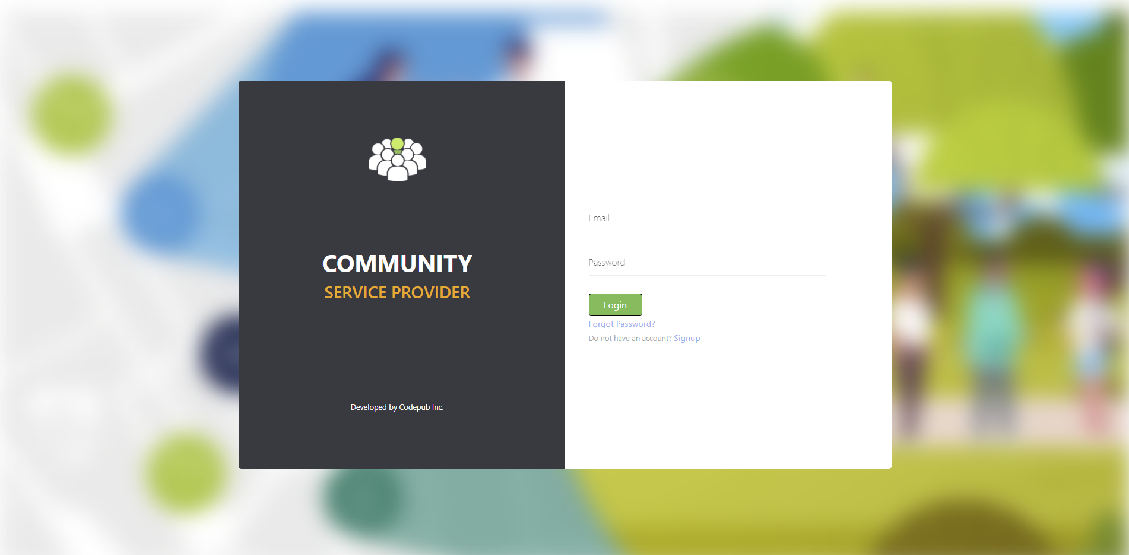

Figure : Login Screen (User End Website)

* A signup screen through which user can create a new account.

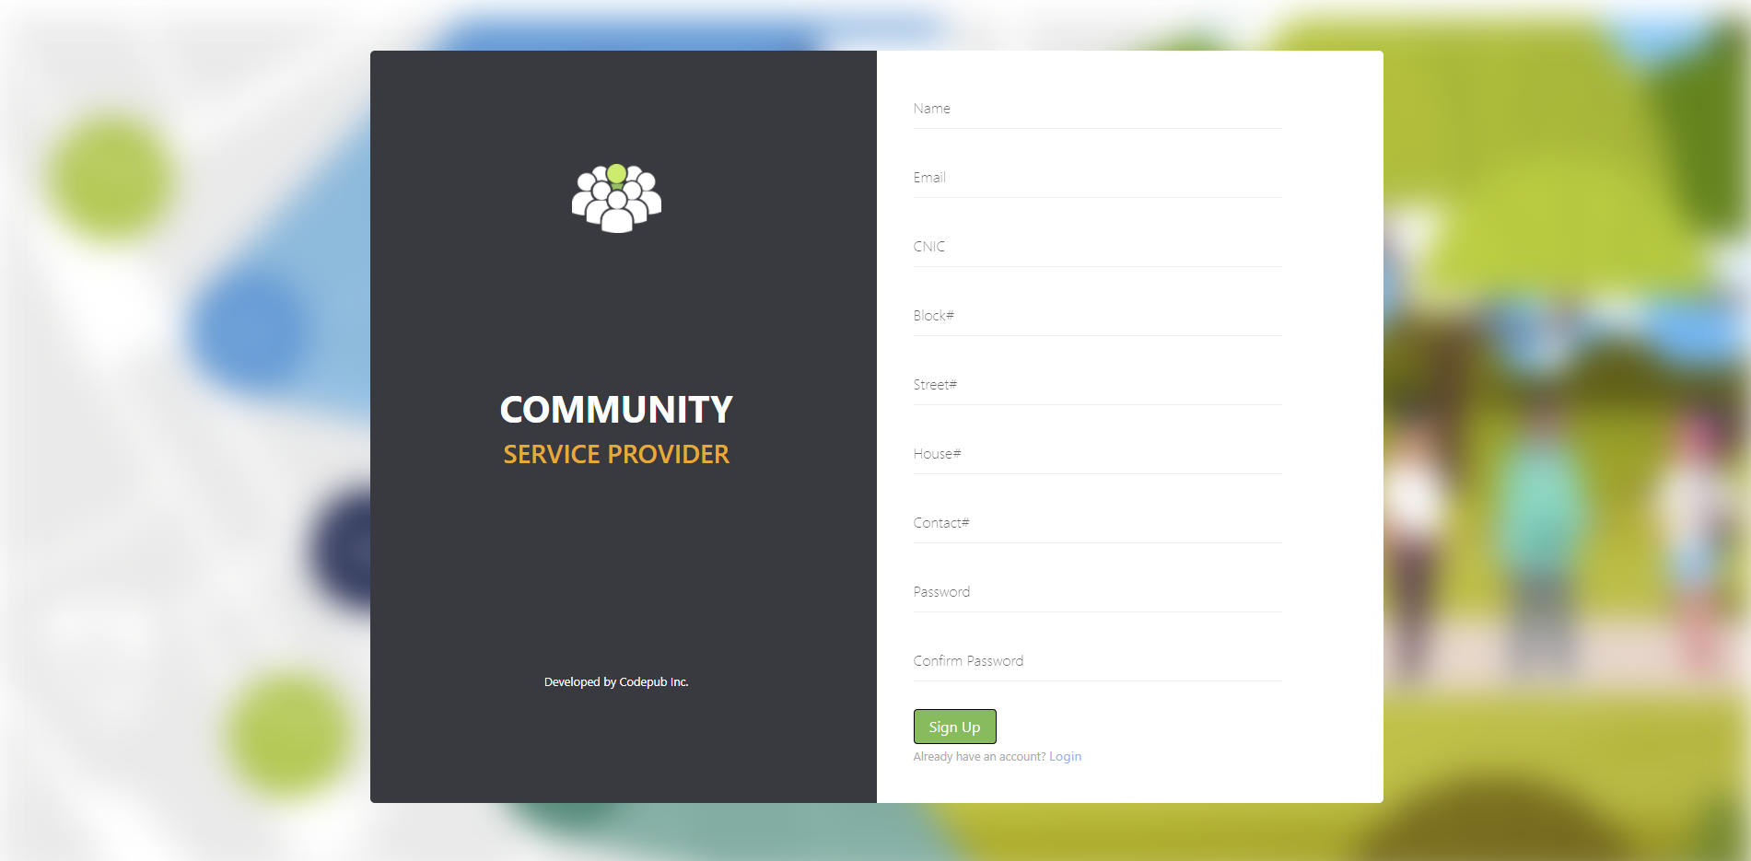

Figure : Signup Screen (User End Website)

#### **Home (Website)**

A home screen that displays information regarding available services.

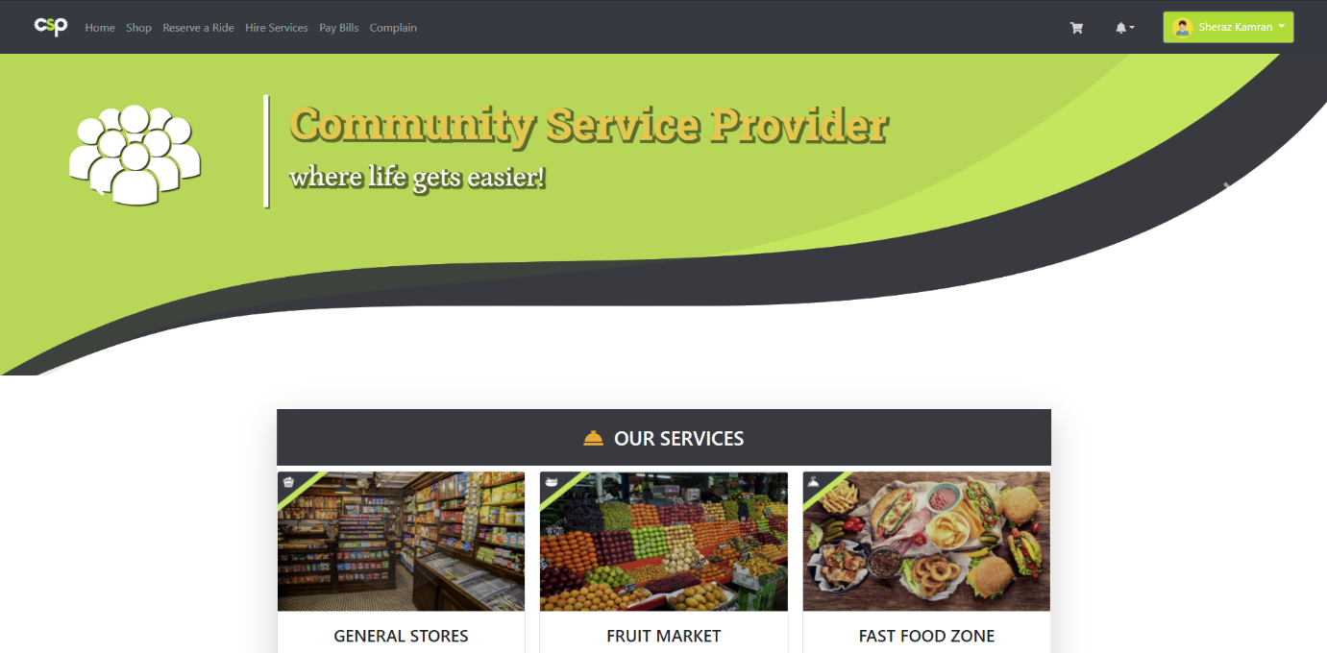

Figure : Home Screen 1 (User End Website)

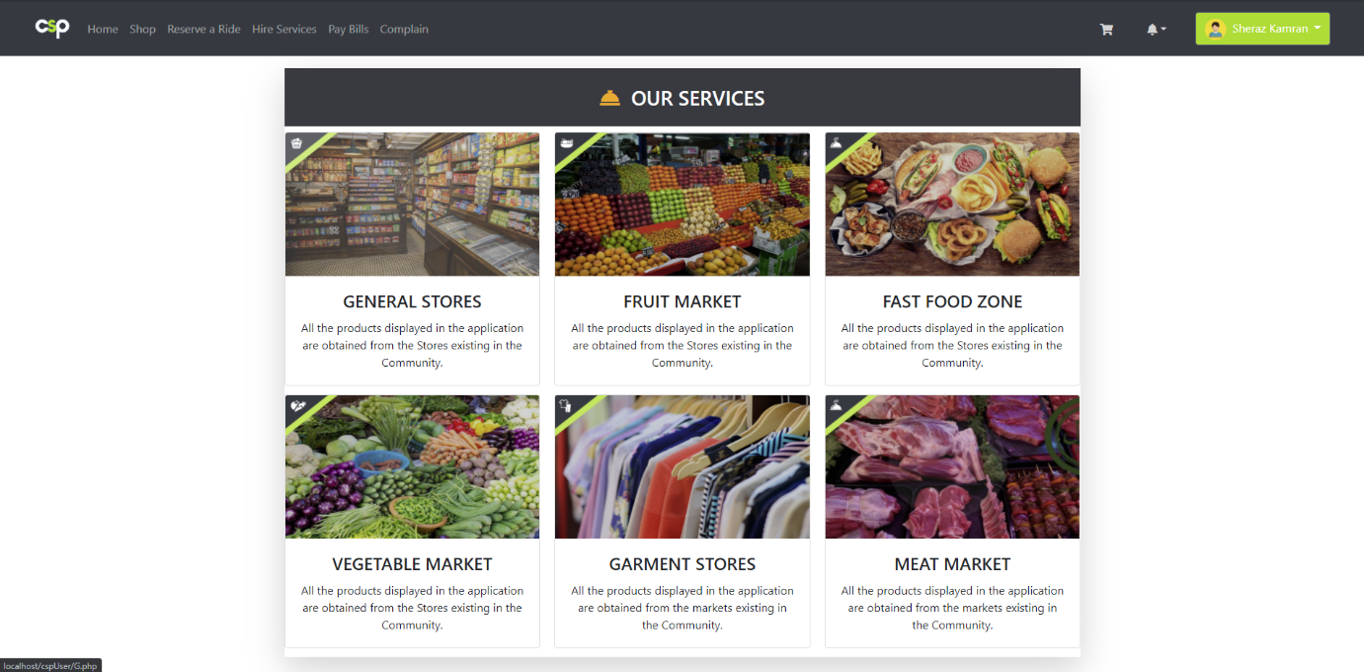

Figure : Home Screen 2 (User End Website)

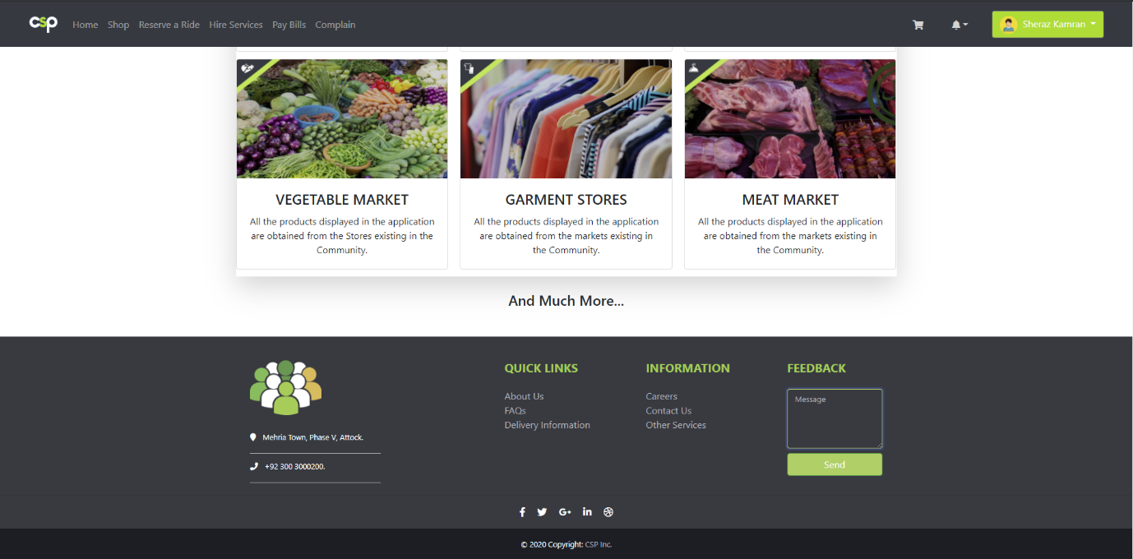

Figure : Home Screen 3 (User End Website)

#### **Shop (Website)**

A shop screen that provides simply aestheticized control visuals and displays products and items for sale.

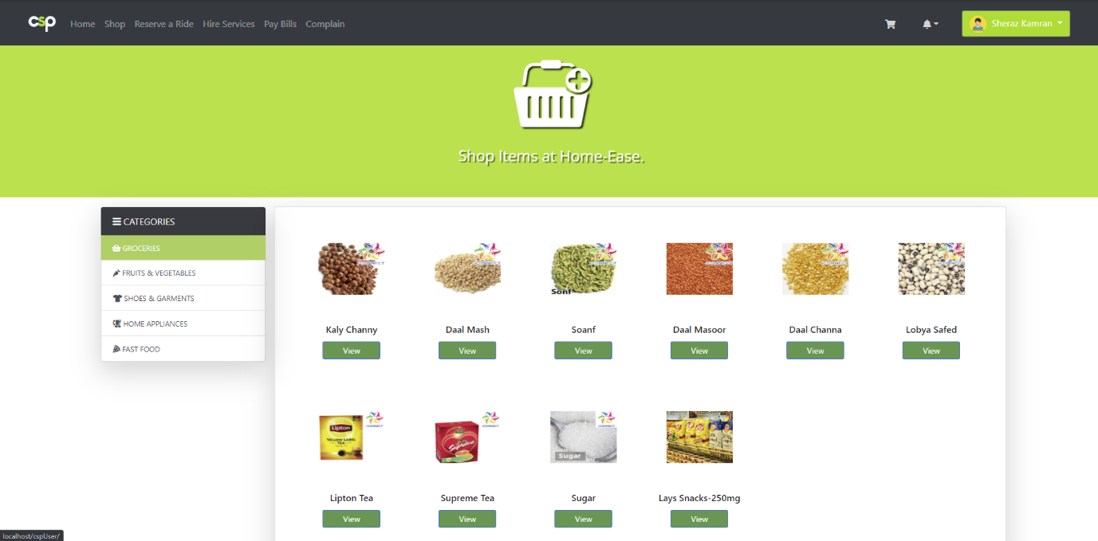

Figure : Shop Screen 1 (User End Website)

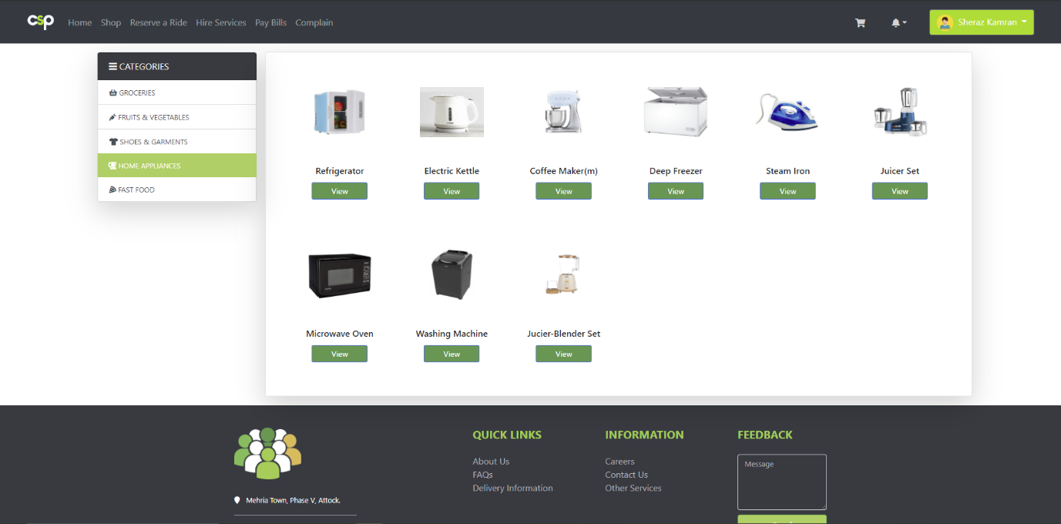

Figure : Shop Screen 2 (User End Website)

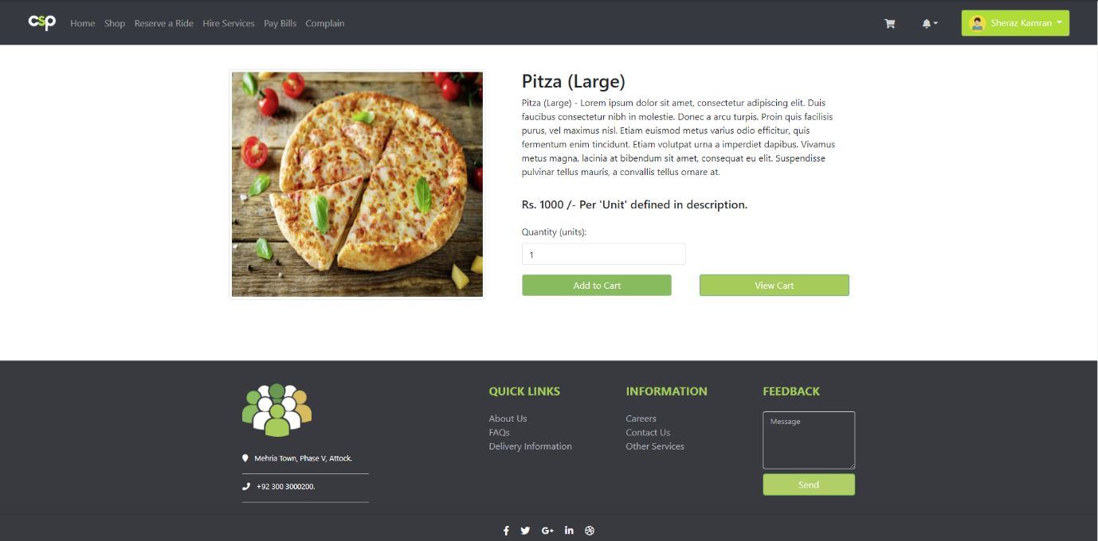

Figure : Shop Screen 3 (User End Website)

#### **Reserve a Ride (Website)**

A car booking screen to allow users to rent a ride of their choice at an instance of few clicks.

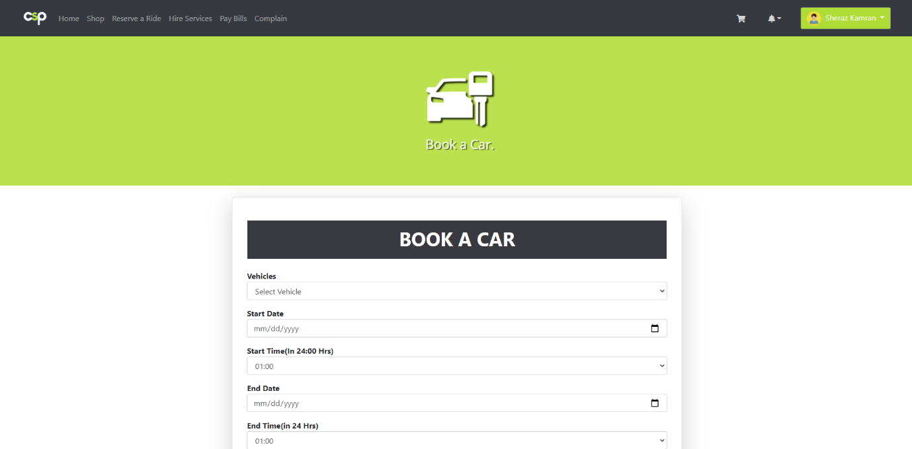

Figure : Booking Screen 1 (User End Website)

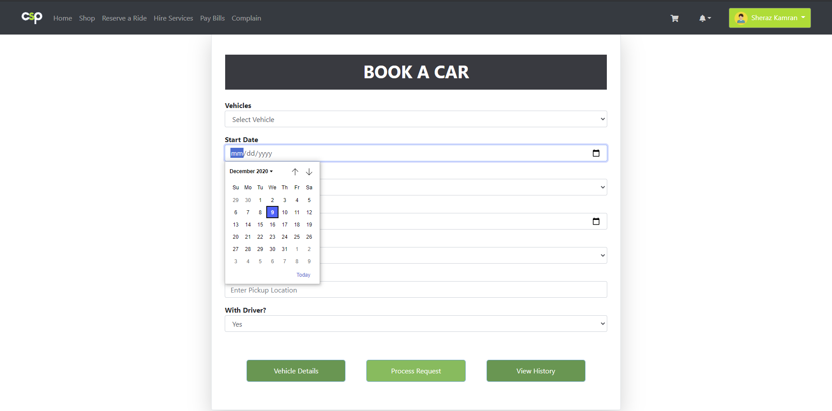

Figure : Booking Screen 2 (User End Website)

#### **Hire Service (Website)**

A hire service screen that facilitates a user with the hiring of a professional serviceman of his choice.

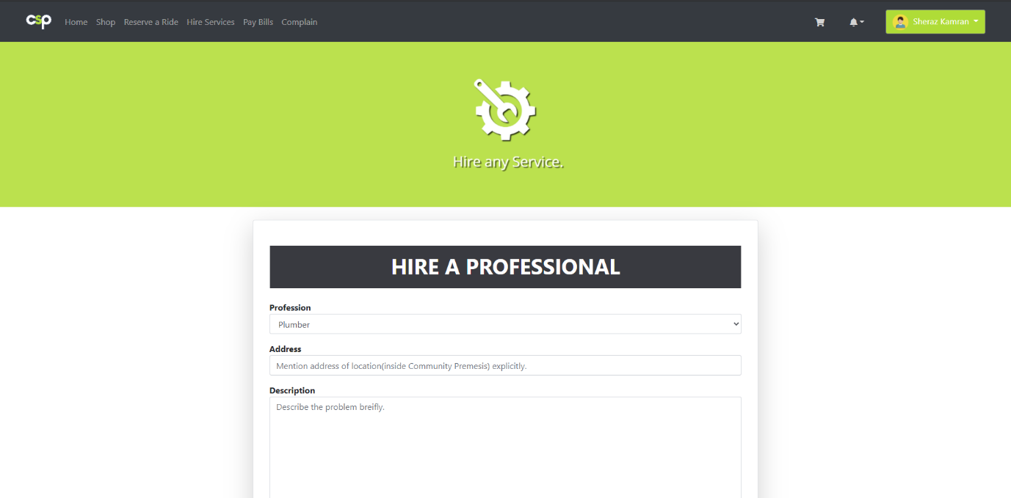

Figure : Hire Service Screen 1 (User End Website)

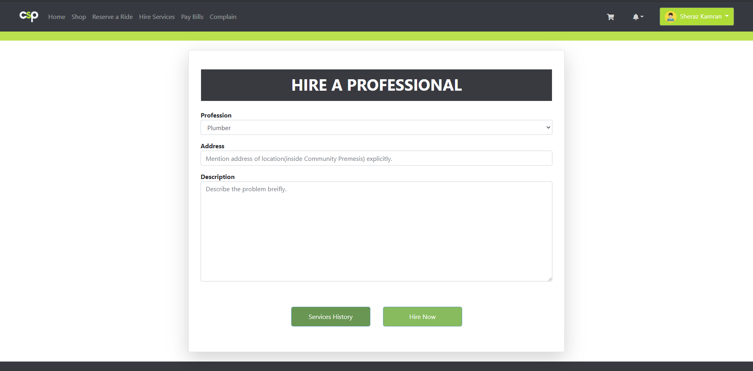

Figure : Hire Service Screen 2 (User End Website)

#### **Pay Bills (Website)**

A Pay Bills screen that allows its user to pay his utility bills anywhere, anytime.

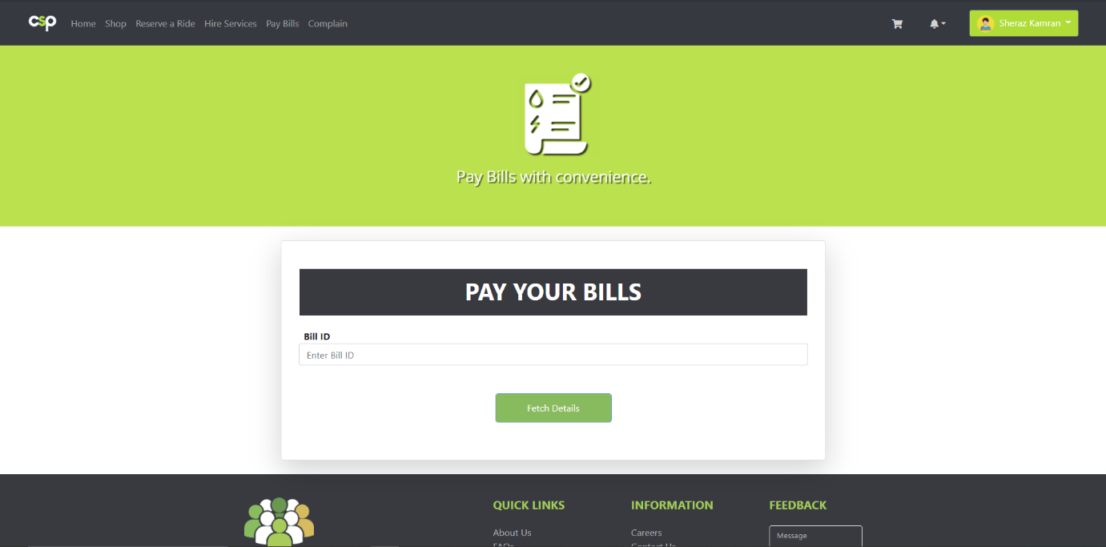

Figure : Pay Bills Screen 1 (User End Website)

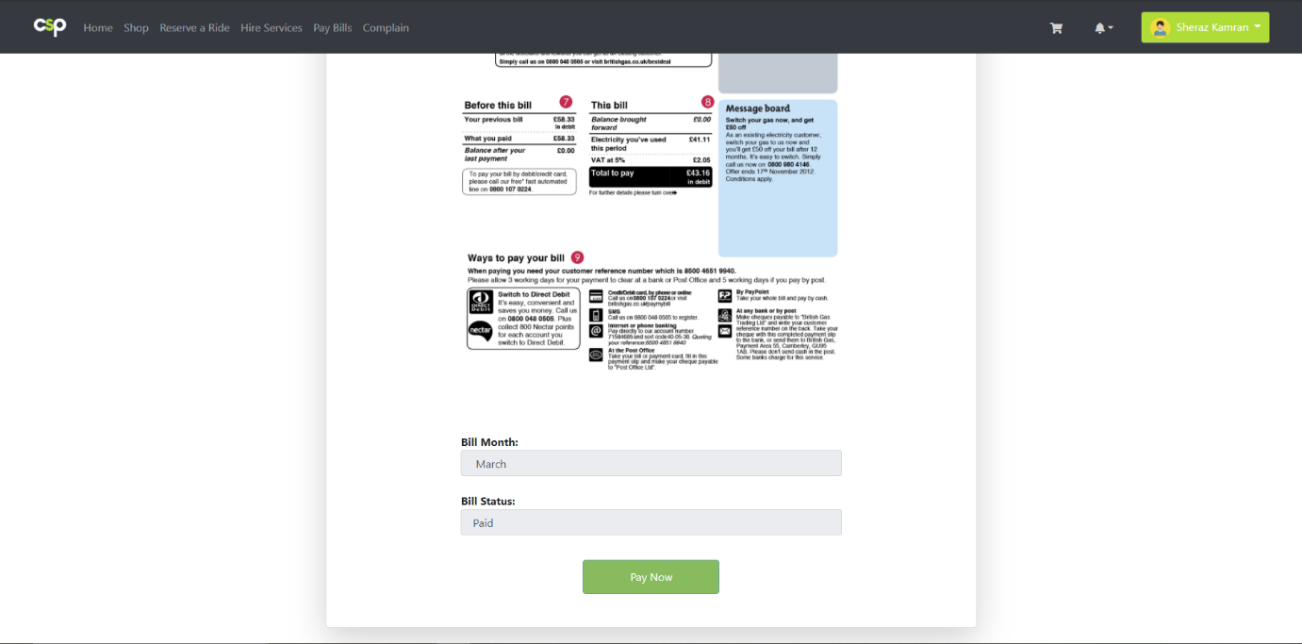

Figure : Pay Bills Screen 2 (User End Website)

#### **Complain (Website)**

A complain portal that provides the needed facility of putting online complaints to its users.

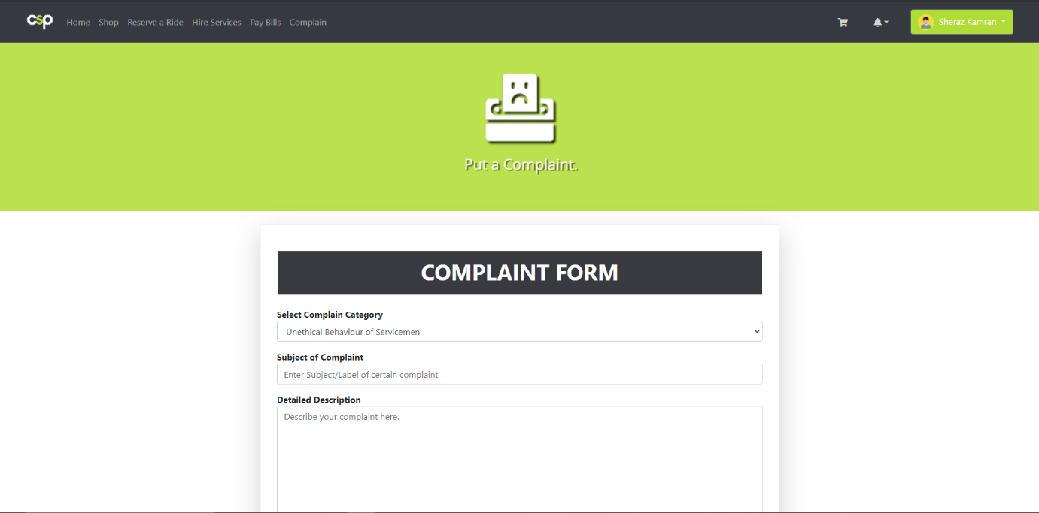

Figure : Complain Screen 1 (User End Website)

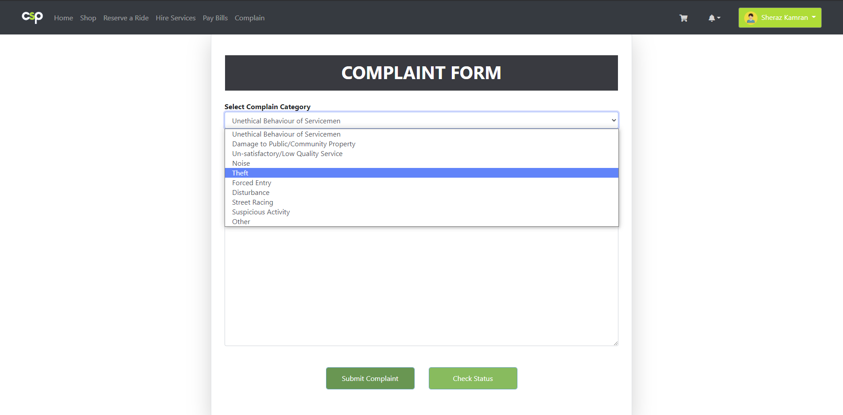

Figure : Complain Screen 2 (User End Website)

### **User End Android App**

#### **Login and Sign Up (Android App)**

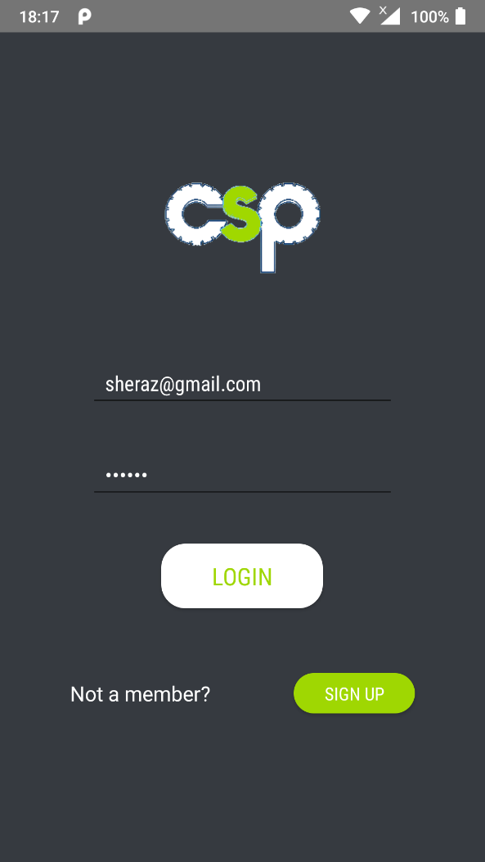

Figure : Login Screen (User End App)

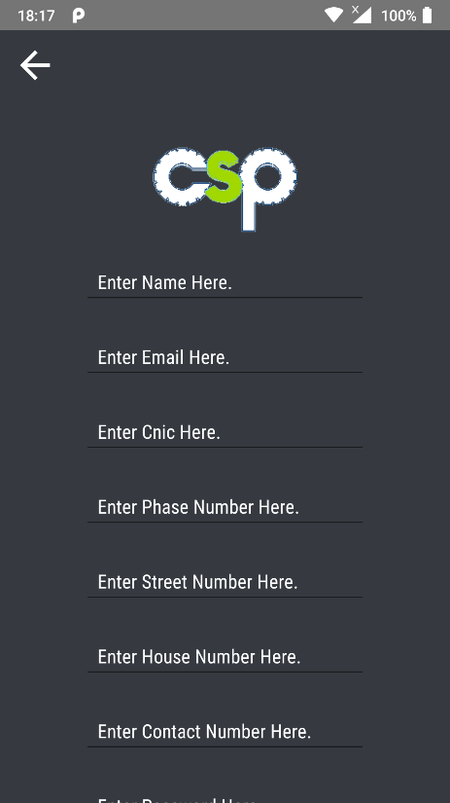

Figure : Sign Up Screen (User End App)

#### **Home (User End Android App)**

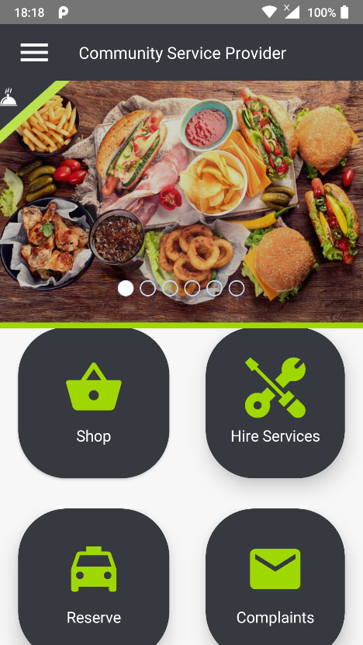

Figure : Home Screen (User End App)

#### **Shop (User End Android App)**

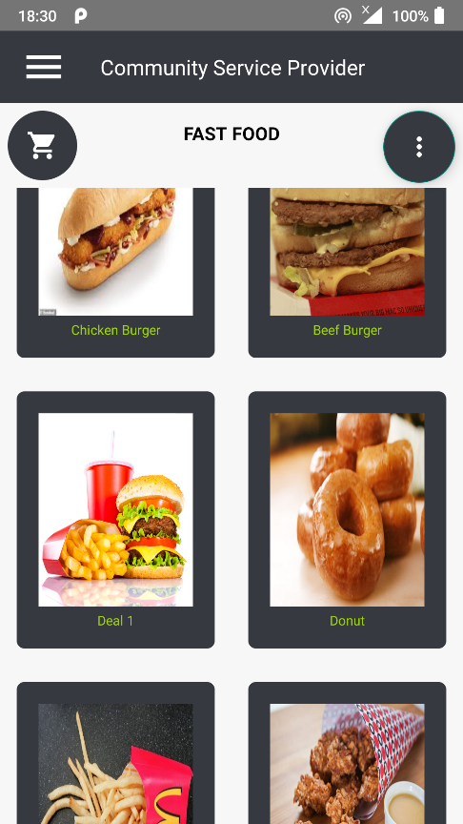

Figure : Shop Screen 1 (User End App)

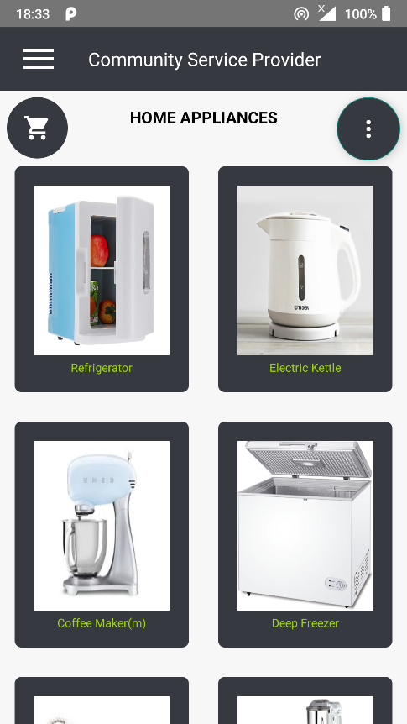

Figure : Shop Screen 2 (User End App)

#### **Hire Service (User End Android App)**

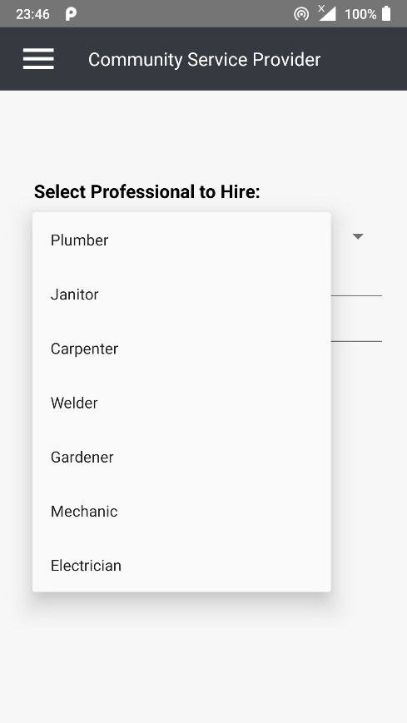

Figure : Hire Service Screen (User End Android App)

#### **Pay Bills (User End Android App)**

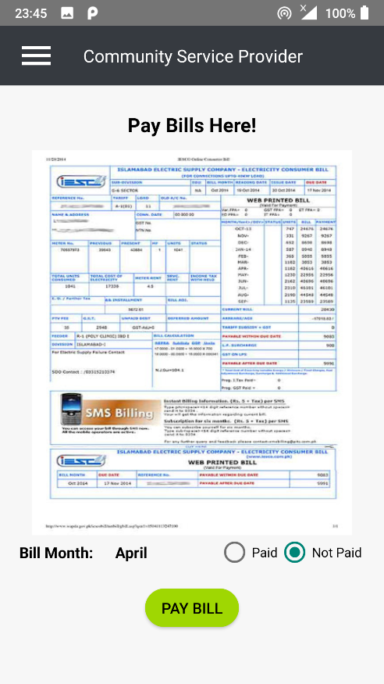

Figure : Pay Bills Screen (User End Android App)

#### **Complain (User End Android App)**

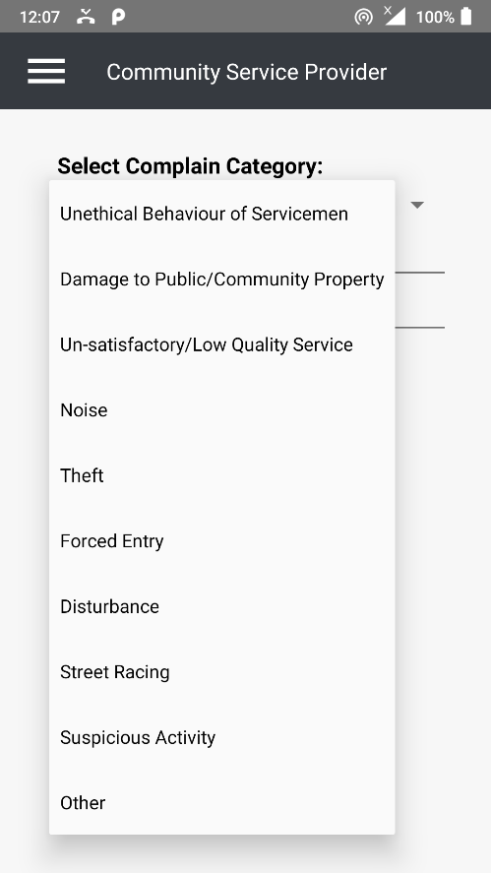

Figure : Complain Screen 1 (User End Android App)

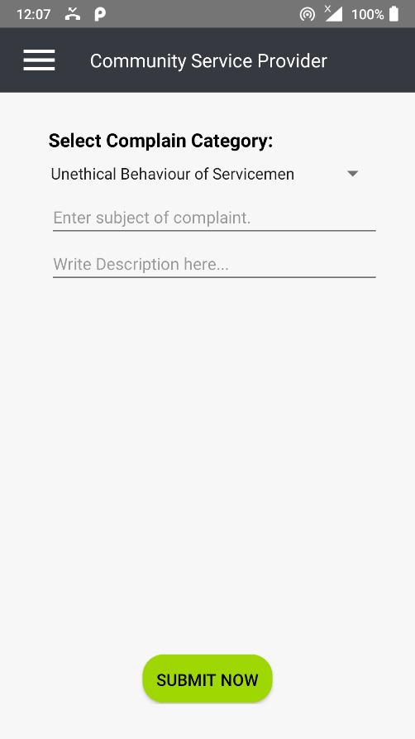

Figure : Complain Screen 2 (User End Android App)

### **Management End Web Portal**

Community Service Provider’s manager end is designed in a way to provide instant access to its controls. Mostly, all the important controls are placed on a single screen and the aesthetic is kept simple for keeping it smooth and fast. Some of the screens are as follows,

#### **Login (Manager End Web Portal)**

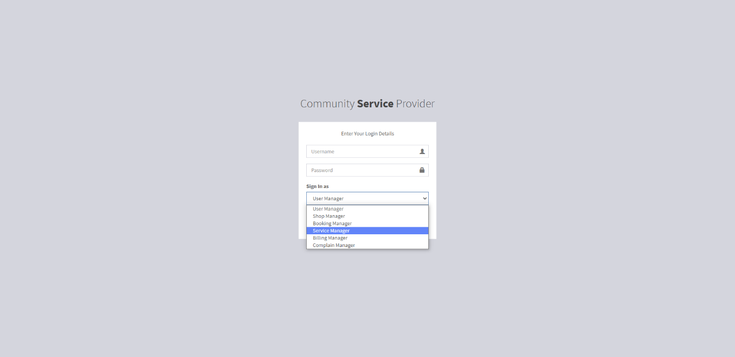

Figure : Login Screen (Manager End Web Portal)

#### **Home (Manager End Web Portal)**

* *User* Manager End

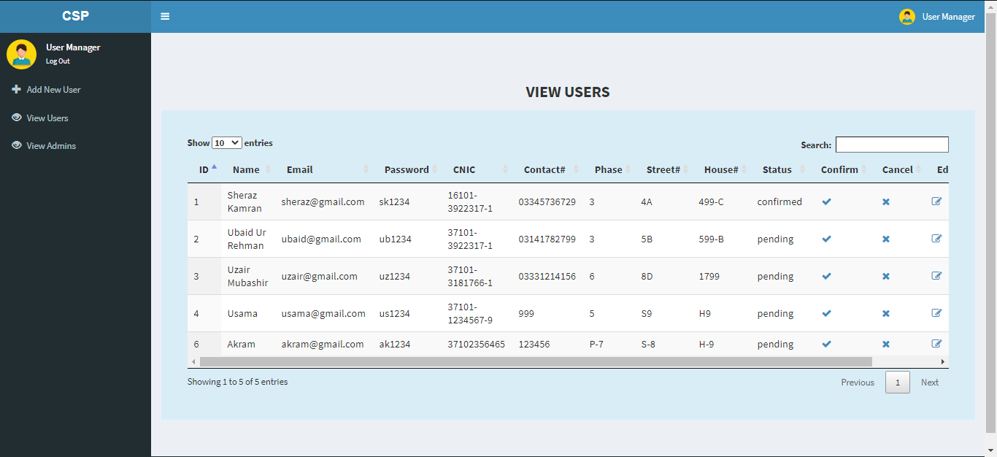

Figure :Home Screen-User Manager (Manager End Web Portal)

* Shop Manager End

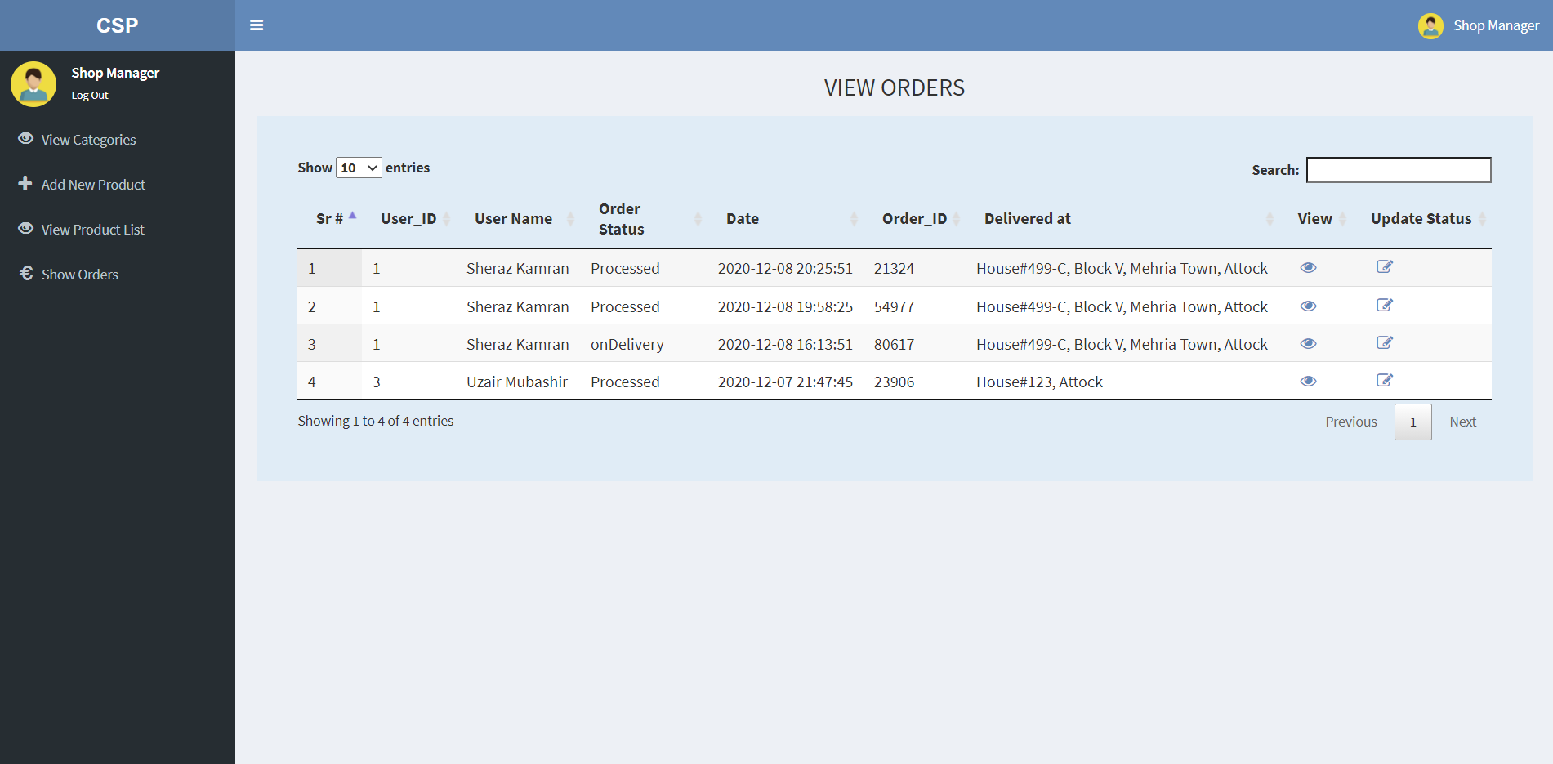

Figure : Home Screen-Shop Manager (Manager End Web Portal)

* Booking Manager

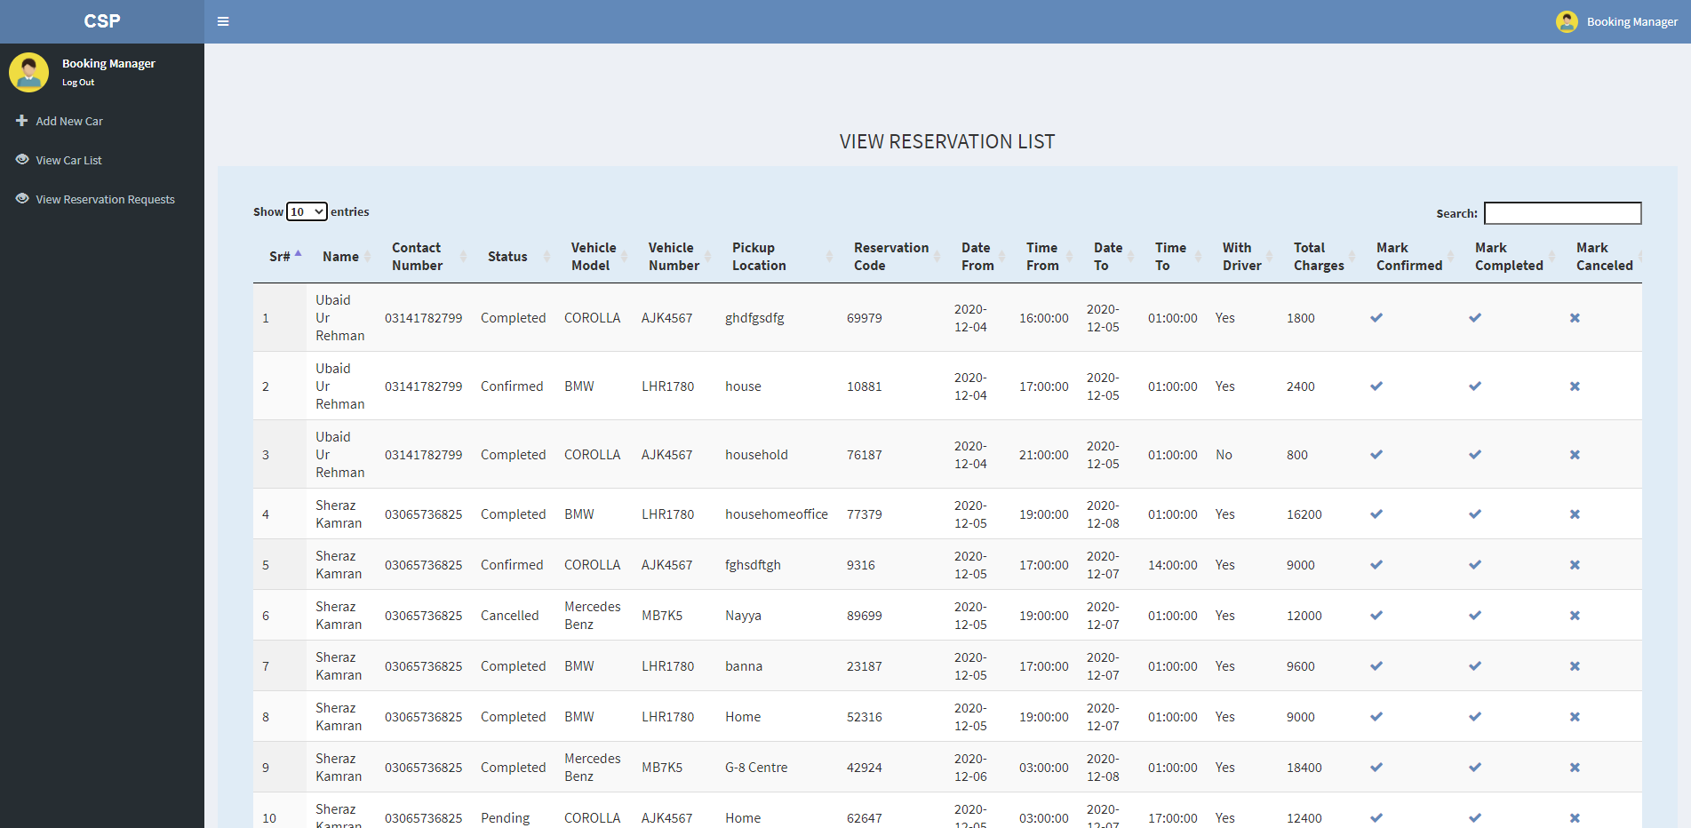

Figure : Home Screen-Booking Manager (Manager End Web Portal)

* Service Manager

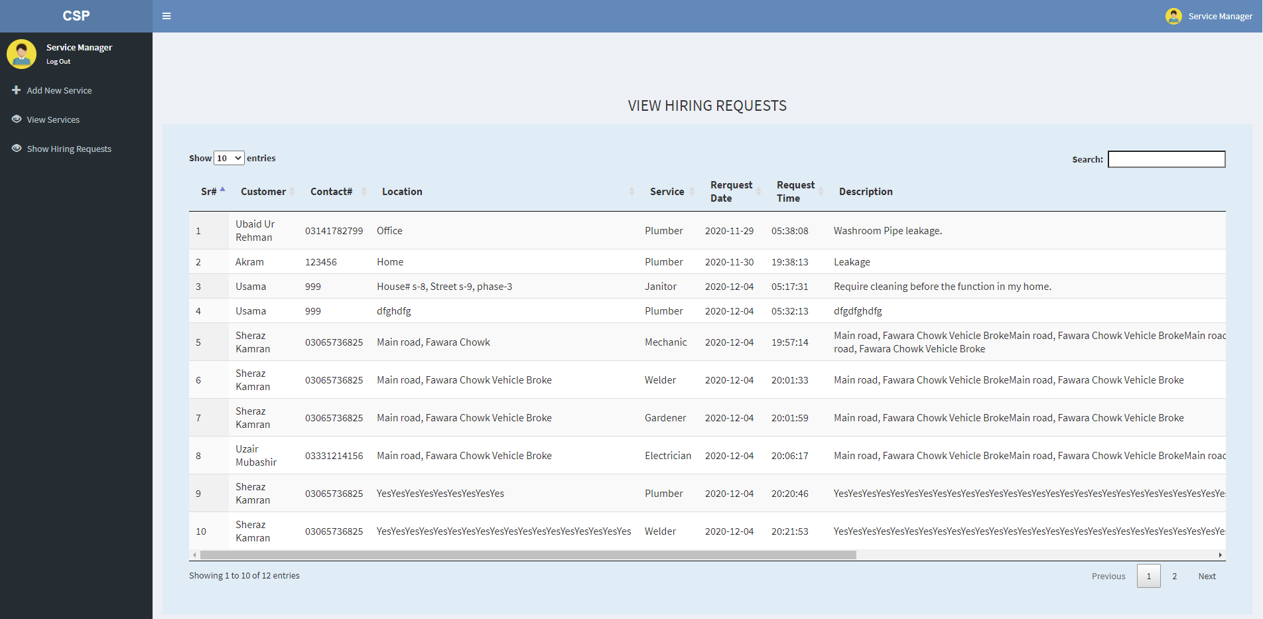

Figure : Home Screen-Service Manager (Manager End Web Portal)

* Billing Manager

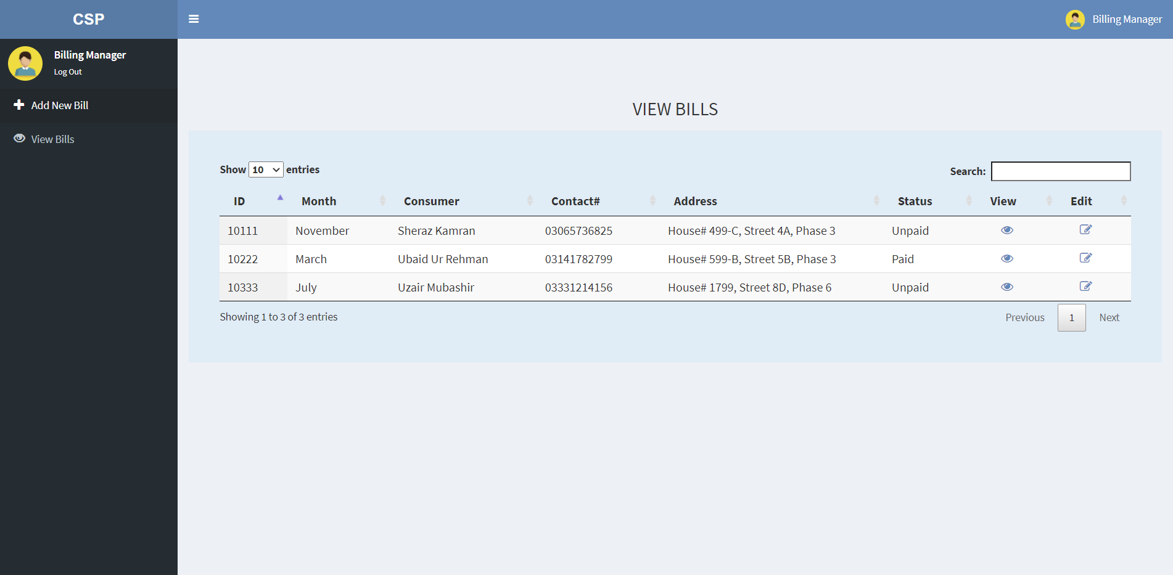

Figure : Home Screen-Billing Manager (Manager End Web Portal)

* Complain Manager

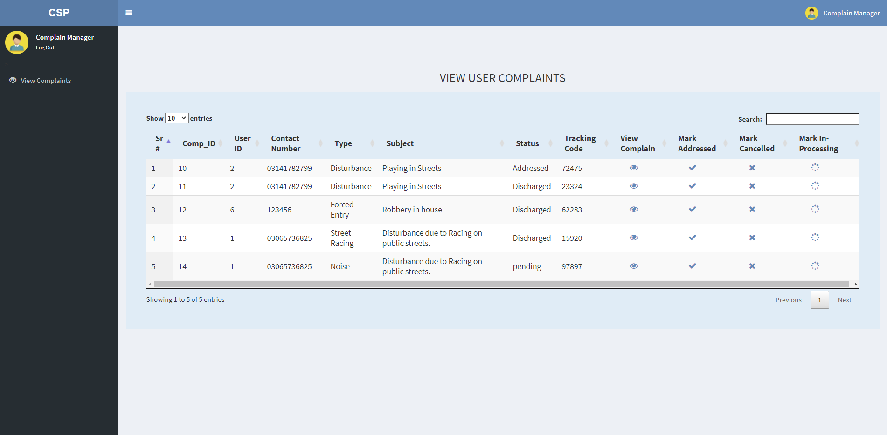

Figure : Home Screen-Complain Manager (Manager End Web Portal)

# **Evaluation and Testing**

This step is one of the most important and crucial steps of SDLC. Testing and evaluation helps us to improve our system to make it closer to the requirements. It helps us in developing a quality product. It guarantees the certification and nature of the item that whether it is up to the check or not and whether every one of the prerequisites of client are being satisfied or not. It also helps the designer and programmer to learn from errors and come up with innovative solutions.

## **Testing Objectives**

The main purpose of testing the applications is to bring up the errors that cause the applications to run poorly and unable to provide expected results. After discovering these errors, the following points are to be considered as solution for those errors.

## **Selected testing methodology**

For testing the applications, we used manual testing as our testing tool and by using the use case base testing, we can test the functionality of the whole system.

**Test Cases for User End / Website / Android App:**

|  |  |  |  |  |
| --- | --- | --- | --- | --- |
| **Sr #** | **Test Case** | **Attribute & Value** | **Expected Result** | **Result** |
| 1 | User Sign Up | User enters required credentials correctly | Request sent to User Admin | PASS |
| 2 | User Login | User provides correct email and password | User is logged in | PASS |
| 3 | Add items to Cart/Shop | User selects products and clicks on ‘Add to Cart’ button | Items are added to cart successfully | PASS |
| 4 | Edit Cart | User Deletes an item from cart | Item Deleted Successfully | PASS |
| 5 | Checkout | User places an order | Order placed successfully | PASS |
| 6 | Hire Service | User selects the service of choice and clicks on ‘Hire Service’ Button | Request Sent successfully | PASS |
| 7 | Book Car Service | User selects the vehicle of choice and clicks on ‘Bookit’ button | Request sent successfully | PASS |
| 8 | View Bill | User enters bill id and clicks on ‘Fetch Bill’ button | The required bill displayed successfully | PASS |
| 9 | Pay Bill | User selects the payment method of choice and fills the correct required credentials | Payment is done successfully | PASS |
| 10 | Send Complain | User writes complain and clicks on ‘Send’ button | Complain sent successfully | PASS |
| 11 | View Profile | User clicks on Profile button | User profile displayed | PASS |
| 12 | Edit Profile | User Edits info by providing correct data | Edit Request sent successfully | PASS |
| 13 | User Logout | User clicks on ‘Logout’ button | User Logs outs successfully | PASS |

Table : Test Cases for User End / Website / Android App

**Test Cases for Management End / Web Portal:**

|  |  |  |  |  |
| --- | --- | --- | --- | --- |
| **Sr #** | **Test Case** | **Attribute & Value** | **Expected Result** | **Result** |
| 1 | Admin Login | Admin provides correct username and password | Admin is logged in | PASS |
| 3 | Add Item Category | Admin enters required data correctly and clicks on ‘Add’ button | Category added successfully | PASS |
| 4 | Edit Category | Admin Edits/Deletes a category | Category Deleted Successfully | PASS |
| 5 | Add Items/Products | Admins enters required data correctly and click on ‘Add’ button | Item/Product added successfully | PASS |
| 6 | Edit Item/Product | Admin Edits/Deletes an item | Item Edited/Deleted Successfully | PASS |
| 7 | Entertain Placed Orders | Admin Accepts or Denies users’ placed orders | Request Entertained successfully | PASS |
| 8 | Add New Service | Admin fills the required data correctly and clicks on ‘Add’ button | Service added successfully | PASS |
| 9 | Edit Service | Admin Edits/Deletes a Service | Service Edited/Deleted Successfully | PASS |
| 10 | Entertain Requested Services | Admin Accepts or Denies users’ hire requests | Request entertained successfully | PASS |
| 10 | Add New Vehicle | Admin fills the required data correctly and clicks on ‘Add’ button | Vehicle Added Successfully | PASS |
| 11 | Edit Vehicle | Admin Edits/Deletes a Vehicle | Vehicle Edited/Deleted successfully | PASS |
| 12 | Entertain Users’ booking requests | Admin Accepts/Denies users’ booking requests | Request entertained successfully | PASS |
| 13 | Add new Bill | Admin fills the required data correctly and click on ‘Add’ Button | Bill Added successfully | PASS |
| 14 | Edit Bill | Admin Deletes/Edits a Bill | Bill Deleted/Edited Successfully | PASS |
| 15 | Entertain Users’ Complaints | Admin Accepts/Denies users’ sent complaints | Request Entertained successfully | PASS |
| 16 | Admin Logout` | Admin clicks on Logout Button | Admin Logs out successfully | PASS |

Table : Test Cases for Management End / Web Portal

# **Conclusion & Future Work**

This chapter concludes the project and highlights future work.

## **Vision**

Our vision is to digitalize the daily life needs of people living in towns by providing them a fast and user-friendly system which deals with all the daily life services under a single platform. Our aim is to provide convenience not only to the community members but also the town managers by providing them a compact management system.

## **Conclusion**

Community Service Provider is a cross platform full fledge application that provide daily life services and service management services under a single platform. Some of these services include online shopping, booking, service hiring, paying bills etc. It is targeted towards Communities and towns and saves a lot of time and cost of its users. Advanced and latest tools and technologies are adopted to design and develop the project of such sale as well as a lot of effort and passion. The system is tested continuously to make it a reliable and quality product. The aim is to provide convenience to the users and managers alike in their daily life affairs and businesses, respectively.

## **Future Work**

Our goal is to continuously improve and enhance the system by introducing new features and functionalities in the future and to out-source this system in the market. Our team shall provide continuous maintenance and customization support and try to make the system as reliable as possible for a better experience.

# **References**

[1] Inc., A. (n.d.). Retrieved from Amazon: https://www.amazon.com/

[2] Pakistan, G. o. (n.d.). Retrieved from Pakistan Citizen Portal: https://play.google.com/store/apps/details?id=com.govpk.citizensportal&hl=en